

**Group Leader:**

HAMZA (02-131192-070)

**Group Members:**

ABDUL HANNAN (02-131192-058)

MUHAMMAD HARIS SARWAR (02-131192-073)

**Project Title:**

HOSPITAL SYSTEM

**Submitted To:**

SIR REHAN BAIG

**Table of Contents**

1. Abstract……………………………………………………………………….............1

2. Introduction…………………………………………………………………………...1

3. Solution……………………………………………………………………………….. 2

3.1 Desktop Application………………………………………………………...1

3.2 Website……………………………………………………………………...1

4. Presentation.................................................................................................................... 1

5. Programs……………………………………………………………………………….2

6. Conclusion……………………………………………………………………………..1

1. **ABSTRACT:**

In this project we use MS Access and Sublime to create a hospital system. In MS Access we create Database, Forms, Reports of doctor and patient record. In sublime we use CSS, html, bootstrap to form a web page of hospital system that include home page, about, contact, doctors.

1. **INTORDUCTION:**As Shaheen City hospital is a health care institution providing patient treatment with specialized medical and nursing staff and medical equipment. At Shaheen City Hospital we provide all types of necessities to our patients. This hospital is a tertiary care hospital with consultant doctors specialized to provide compassionate care and treatment to patients with a full range and severity of specialty diseases and conditions.  Our fully equipped emergency rooms, high tech operating rooms, well equipped critical and intensive care units, comfortable general hospital wards and premium private wing wards have all been designed to ensure a high standard of quality care for all our admitted patients.

**Our Mission and Vision:**

To be committed to excellence in all of our services to our patients so that we may help them achieve the highest level of dental health appropriate for their needs in an atmosphere of trust and compassion. We will continually update ourselves regarding the best and most current materials and technology available.

**Our Facilities:**

We facilitate our patients with clinical nutrition and cafeteria, emergency care, cancer center, cardiology and financial help for needy ones.

**Our Doctors:**

At Shaheen City Hospital, we have best specialist surgeons for patients like ENT, OPD, Cardiology and Skin.

1. **SOLUTION:**

In this part we show solutions of desktop application which we make by using MS Access and we show a website to you.

* 1. **DESKTOP APPLICATION:**  
     Doctor Record:

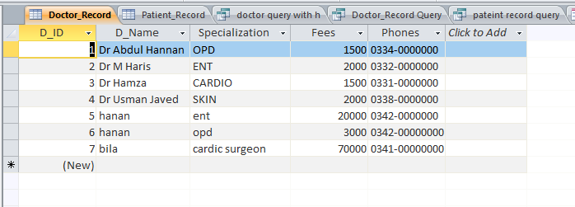

Doctor Form:

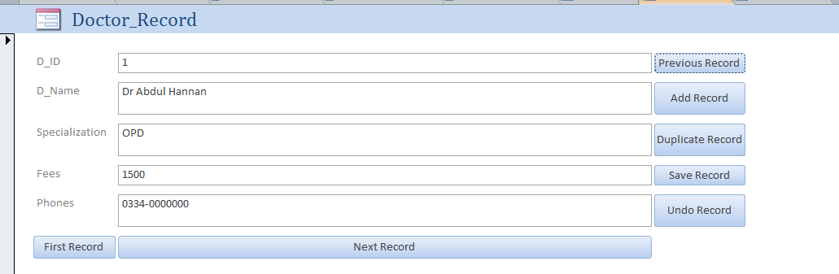

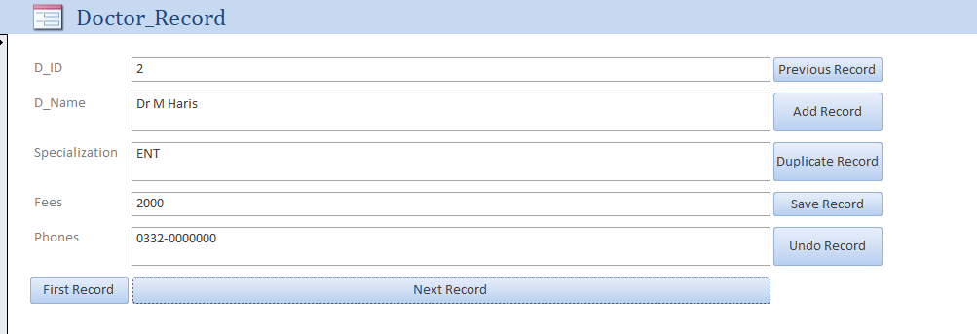

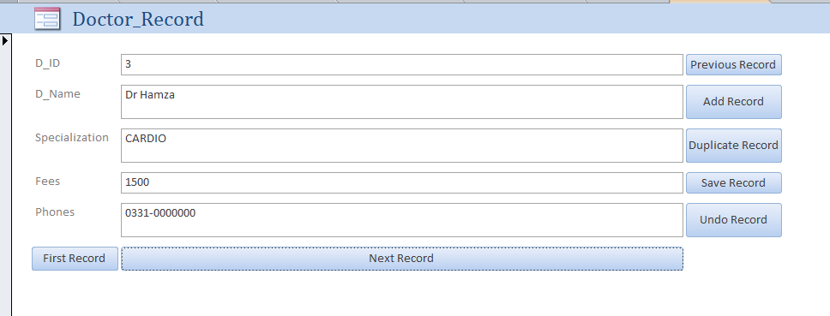

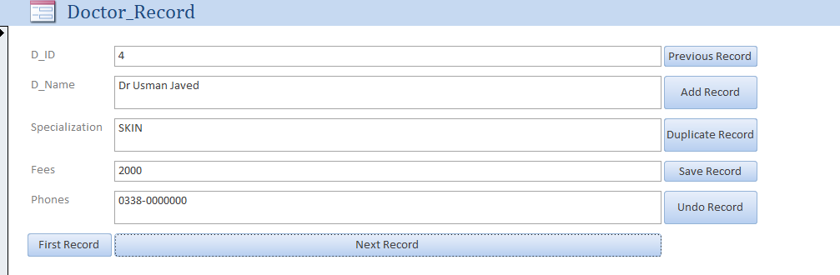

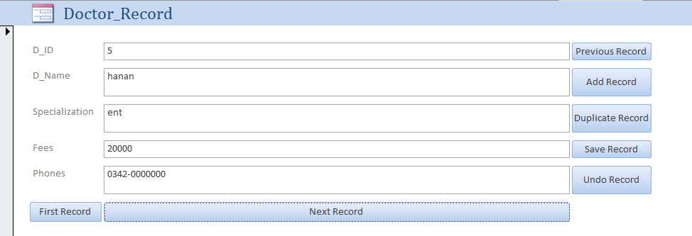

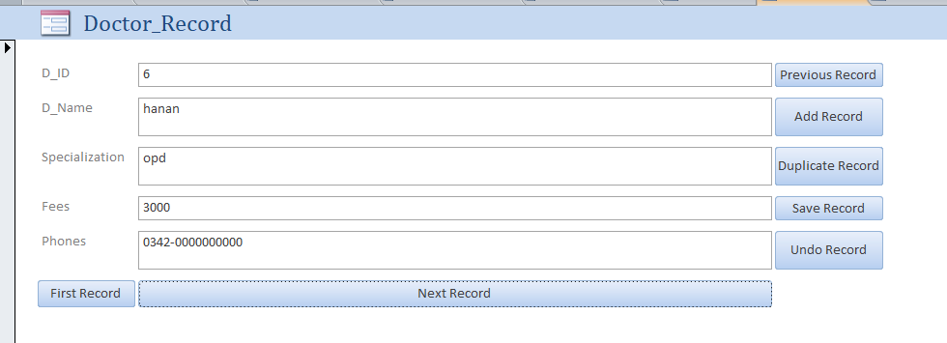

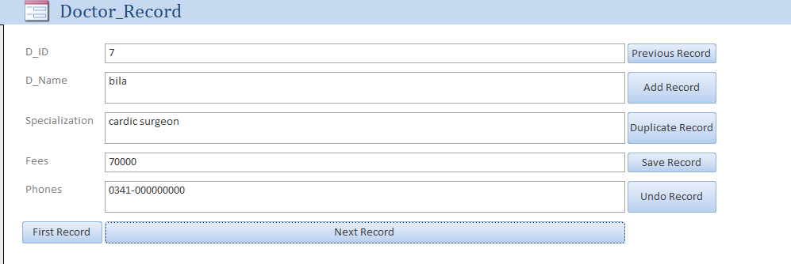

Before Entering Data:

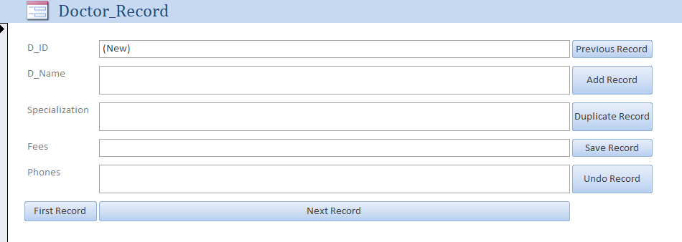

After Entering Data:

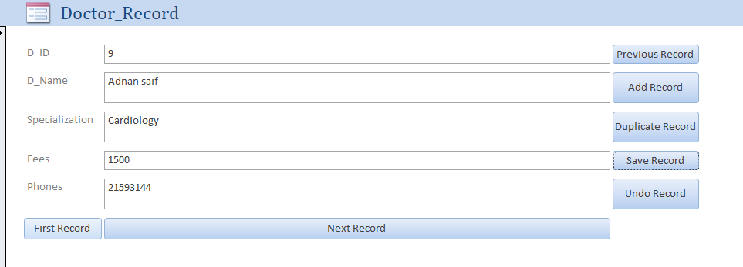

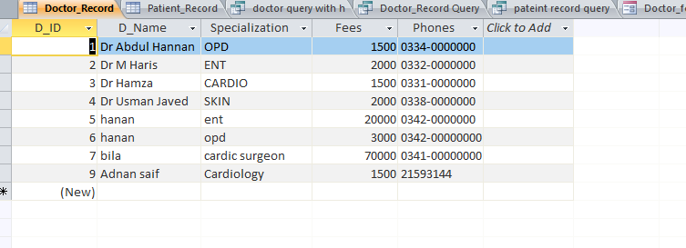

Patient Record:

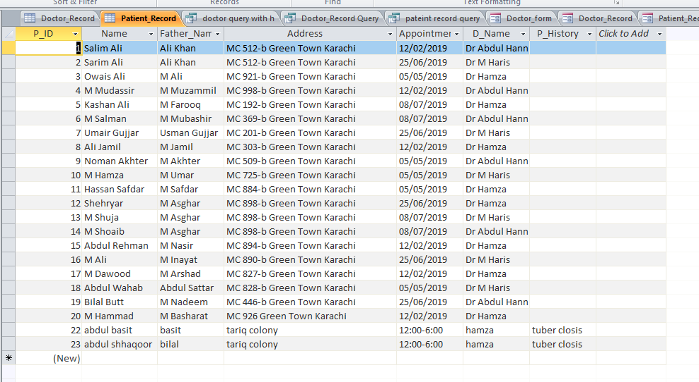

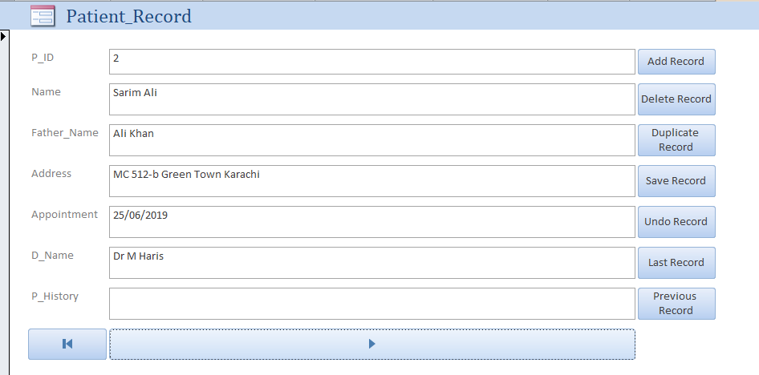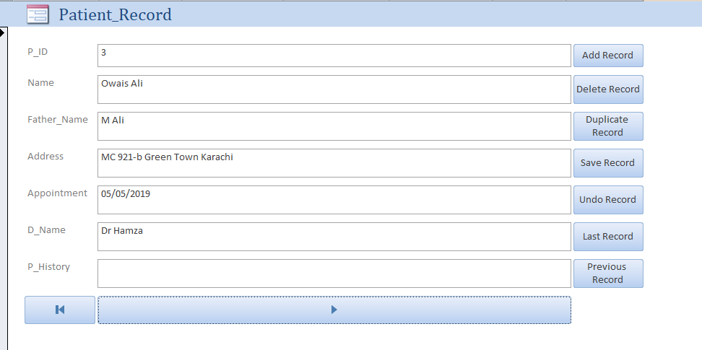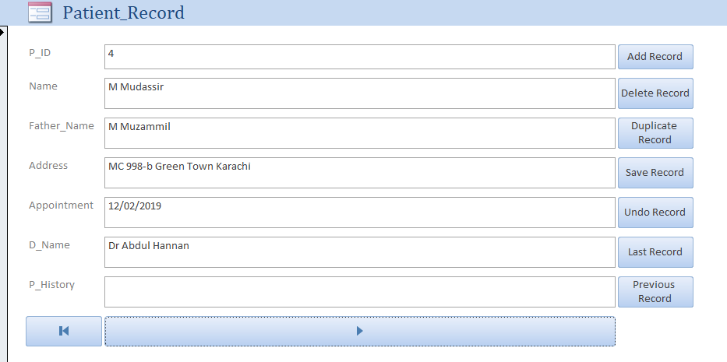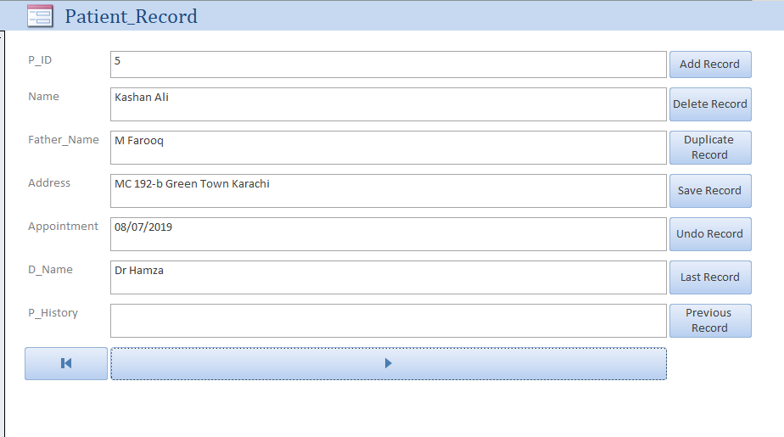

Before Entering Data:

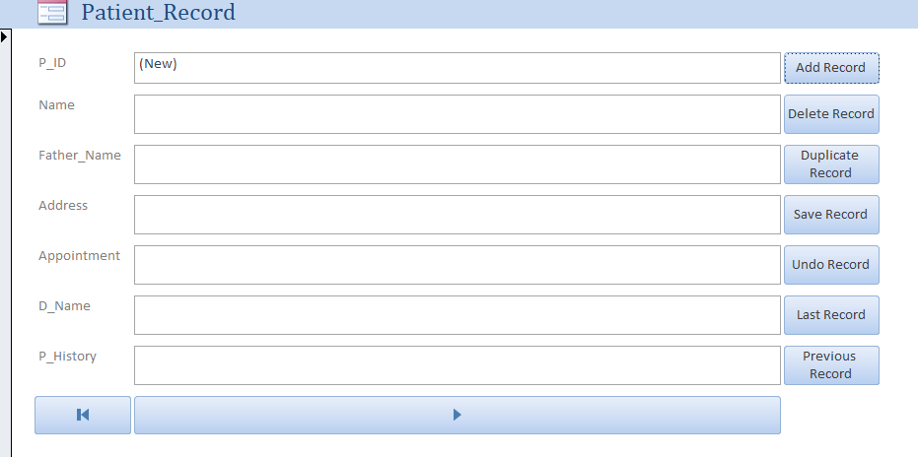

After Entering Data:

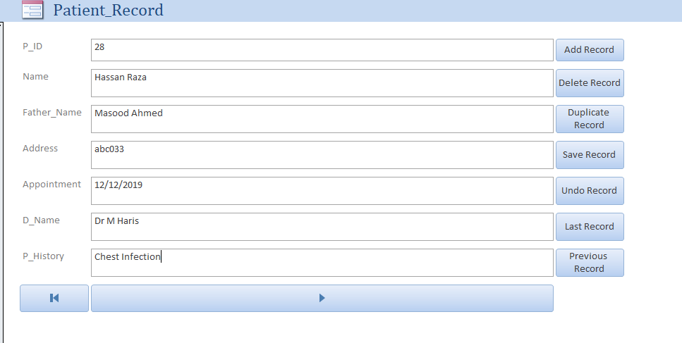

Reports:

Patient Report:

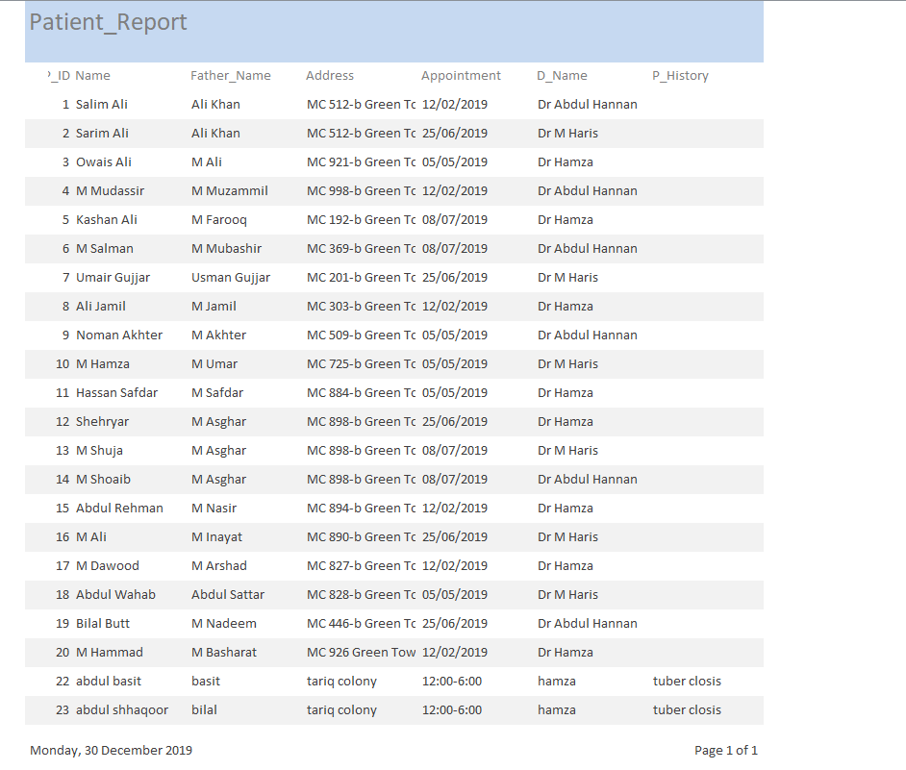

Doctor Report:

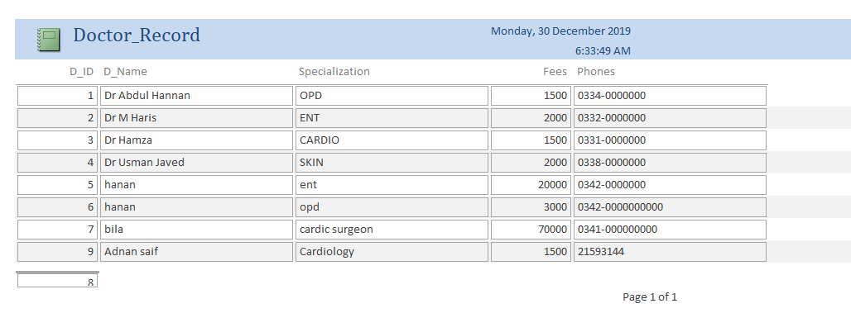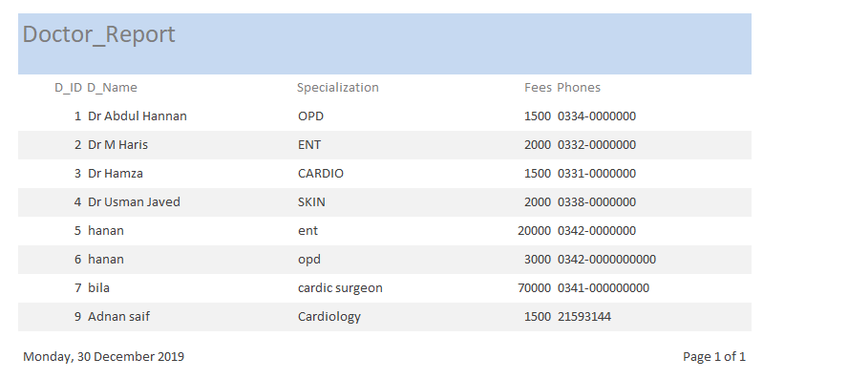

* 1. **WEBSITE / WEBPAGE:**

Home Page:

<!DOCTYPE html>

<html>

<head>

<meta charset="utf-8">

<meta name="viewport" content="width=device-width, initial-scale=1">

<title>HOME</title>

<link rel="stylesheet" type="text/css" href="style.css">

<link href='http://fonts.googleapis.com/css?family=Montserrat:400,700%7CPT+Serif:400,700,400italic' rel='stylesheet'>

<link href="https://fonts.googleapis.com/css?family=Montserrat|Open+Sans" rel="stylesheet">

</head>

<style type="text/css">

*{

margin:0px;

padding:0px;

}

.bgimage{

background-image: url('d2.jpg');

background-size: 100% 110%;

width: 100%;

height: 100vh;

}

.menu{

width: 100%;

height: 150px;

background-color:#5DADE2;

}

.leftmenu{

width: 30%;

line-height: 0px;

float: left;

/* background-color: yellow;*/

}

.leftmenu h4{

padding-left: 50px;

font-weight: bold;

color: white;

font-size: 25px;

font-family: 'Montserrat', sans-serif;

}

.rightmenu{

line-height: 200px;

width:70%;

height: 100px;

float: right;

/* background-color: red; */

}

.rightmenu ul{

margin-left: 100px;

}

.rightmenu ul li {

float: left;

font-family: 'Montserrat', sans-serif;

display: inline-block;

list-style: none;

font-size: 15px;

color:white;

font-weight: bold;

line-height: 200px;

margin-left: 20px;

text-transform: uppercase;

}

#fisrtlist{

color: orange;

}

.rightmenu ul li:hover{

color: orange;

}

.text{

width: 100%;

margin-top: 185px;

text-transform: uppercase;

text-align: center;

color:white;

}

.text h4{

font-size: 14px;

font-family: 'Open Sans', sans-serif;

}

.text h1{

font-size:62px;

font-family: 'Montserrat', sans-serif;

font-weight: 700px;

margin:14px 0px;

animation: 1.5s;

color: #3333 ;

}

.buttonone{

background-color: #212F3C;

border: none;

font-size: 12px;

font-weight: bold;

text-transform: uppercase;

line-height: 40px;

width: 300px;

font-family: 'Montserrat', sans-serif;

margin-top: 25px;

border: 3px solid white;

}

.buttonone:hover{

color: orange;

background-color: rgb(97, 106, 107);

}

.buttontwo{

background-color: #212F3C;

border: none;

font-family: 'Montserrat', sans-serif;

text-transform: uppercase;

font-weight: bold;

line-height: 40px;

border: 3px solid white;

width: 300px;

}

.buttontwo:hover{

color: orange;

background-color: rgb(97, 106, 107);

}

.navimg{

padding-left: 0px;

}

body{

margin: 0;

padding: 0;

font-family: "montserrat";

}

.team-section{

background: #f1f1f1;

text-align: center;

}

.inner-width{

max-width: 1200px;

margin: auto;

padding: 40px;

color: #333;

overflow: hidden;

}

.team-section h1{

font-size: 15px 0;

text-transform: uppercase;

display: inline-block;

border-bottom: 4px solid;

padding-bottom: 10px;

}

.pe{

float: left;

width: calc(100% / 5);

overflow: hidden;

padding: 65PX;

transition: 0.4s;

}

.pe:hover{

background: #ddd;

}

.pe img{

width: 120px;

height: 120px;

}

.p-name{

margin: 16px 0;

text-transform: uppercase;

}

.p-des{

font-style: italic;

color: #3498db;

}

.p-sm{

margin-top: 12px;

}

.p-sm a{

margin: 0 4px;

display: inline-block;

width: 30px;

height: 30px;

transition: 0.4s;

}

.p-sm a:hover{

transform: scale(1.3);

}

.p-sm a i{

color: #333;

line-height: 30px;

}

@media screen and (max-width:600px) {

.pe{

width: 100%;

}

}

body, html{

height:100%;

margin:0;

font-size:16px;

font-family:"Lato", sans-serif;

font-weight:400;

line-height:1.8em;

color:#666;

}

.pimg1, .pimg2, .pimg3{

position:relative;

opacity:0.70;

background-position:center;

background-size:cover;

background-repeat:no-repeat;

/*

fixed = parallax

scroll = normal

*/

background-attachment:fixed;

}

.pimg1{

background-image:url('32.jpg');

min-height:100%;

}

.pimg2{

background-image:url('31.jpg');

min-height:400px;

}

.pimg3{

background-image:url('39.png');

min-height:400px;

}

.section{

text-align:center;

padding:50px 80px;

}

.section-light{

background-color:#f4f4f4;

color:#666;

}

.section-dark{

background-color:#282e34;

color:#ddd;

}

.ptext{

position:absolute;

top:50%;

width:100%;

text-align:center;

color:#000;

font-size:27px;

letter-spacing:8px;

text-transform:uppercase;

}

.ptext .border{

background-color:#111;

color:#fff;

padding:20px;

}

.ptext .border.trans{

background-color:transparent;

}

@media(max-width:568px){

.pimg1, .pimg2, .pimg3{

background-attachment:scroll;

}

}

</style>

<body>

<link rel="stylesheet" href="https://cdnjs.cloudflare.com/ajax/libs/font-awesome/4.7.0/css/font-awesome.min.css">

<style>

body {

font-family: Arial, Helvetica, sans-serif;

}

.navbar {

overflow: hidden;

background-color: #85C1E9 ;

}

.navbar a {

float: left;

font-size: 16px;

color: white;

text-align: center;

padding: 40px;

text-decoration: none;

border-radius: 20px;

}

.dropdown {

float: left;

overflow: hidden;

border-radius: 20px;

}

.dropdown .dropbtn {

font-size: 16px;

border: none;

outline: none;

color: white;

padding: 45px;

background-color: inherit;

font-family: inherit;

margin: 0;

border-radius: 20;

}

.navbar a:hover, .dropdown:hover .dropbtn {

background-color: #E59866 ;

border-radius: 20;

}

.dropdown-content {

display: none;

position: absolute;

background-color: #f9f9f9;

min-width: 160px;

box-shadow: 0px 8px 16px 0px rgba(0,0,0,0.2);

z-index: 1;

border-radius: 20px;

}

.dropdown-content a {

float: none;

color: black;

padding: 12px 16px;

text-decoration: none;

display: block;

text-align: left;

border-radius: 20px;

}

.dropdown-content a:hover {

background-color: #E59866;

border-radius: 20;

}

.dropdown:hover .dropdown-content {

display: block;

border-radius: 20;

}

}

</style>

</style>

</head>

<body>

<div class="navbar">

<img src="LOGO HOSPITAL.png" alt="shaheen city hospital logo"style="float:left; height: 100px;" >

<a href="home.html">HOME</a>

<a href="specialist.html">SPECIALIST</a>

<a href="login.html">LOGIN</a>

<div class="dropdown">

<button class="dropbtn">SERVICES

<i class="fa fa-caret-down"></i>

</button>

<div class="dropdown-content">

<a href="CLINICAL NUTRITION & CAFETERIA.html">CLINICAL NUTRITION & CAFETERIA</a>

<a href="EMERGENCY CARE.html">EMERGENCY CARE</a>

<a href="CANCER CENTER.html">CANCER CENTER</a>

<a href="CARDIOLOGY.html">CARDIOLOGY</a>

<a href="FINANCIAL HELP.html">FINANCIAL HELP TO NEEDY PEOPLE </a>

</div>

</div>

<a href="contact.html">CONTACT US</a>

<div class="dropdown">

<button class="dropbtn">DEPARTMENT

<i class="fa fa-caret-down"></i>

</button>

<div class="dropdown-content">

<a href="ent.html">ENT</a>

<a href="opd.html">OPD</a>

<a href="CARDIO.html">CARDIO</a>

<a href="skin.html">SKIN </a>

</div>

</div>

</div>

</div>

<div class="div img">

<img src="hospital.gif" height="800px" width="100%">

</div>

<div class="text">

<h4> EXCELLENCE IN HEALTH CARE </h4>

<h1> SHAHEEN CITY HOSPITAL </h1>

<h3> WE HAVE THE BEST DOCTORS TO SERVE OUR PATEINTS </h3>

<button id="buttonone" class="buttonone">CHECK CLINIC ONLINE </button>

<button id="buttontwo" class="buttontwo">VIEW DENTAL SERVICES</button>

</div>

</div>

</body>

<body>

<div class="pimg1">

<div class="ptext">

<span class="border">

OUR TERMS AND CONDITION

</span>

</div>

</div>

<section class="section section-light">

<h2>OUR MISSION AND VISION</h2>

<p>

To be committed to excellence in all of our services to our patients so that we may help them achieve the highest level of dental health appropriate for their needs in an atmosphere of trust and compassion.

We at Rogers Dental Center will continually update ourselves regarding the best and most current materials and technology available in dentistry and infection control.

We will treat the patient's dental needs with the highest level of care, skill, judgment and comfort.

We will adapt, grow and evolve with our profession and society.

We will appreciate, communicate and empathize with our patients and our fellow team members so that we may enhance the lives of every person involved in achieving our mission.

</p>

</section>

<div class="pimg2">

<div class="ptext">

<span class="border trans">

</span>

</div>

</div>

<section class="section section-dark">

<h2>OUR STAFF</h2>

<p>

The doctors of Rogers Dental Center are extremely proud of our staff and feel that they're a great asset to our business. This group of highly-trained professionals is excited about what they do, have the highest standards of quality and integrity and are motivated to achieve the best for our patients.

</p>

<h2>Appointments</h2>

<p>

Your scheduled appointment time has been reserved specifically for you. We request a 48-hour notice if you need to cancel your appointment. We are aware that unforeseen events sometimes require missing an appointment. After missing your second appointment without notifying us 48 hours in advance, you are subject to being charged an additional fee.

</p>

<h2>ISURANCE POLICY</h2>

<p>

Our office is committed to helping you maximize your insurance benefits. Because insurance policies vary, we can only estimate your coverage in good faith but cannot guarantee coverage due to the complexities of insurance contracts. Your estimated patient portion must be paid at the time of service. As a service to our patients, we will bill insurance companies for services and allow them 45 days to render payment. After 60 days, you are responsible for the entire balance, paid-in-full. If you have any questions, our courteous staff is always available to answer them.

</p>

</section>

<div class="pimg3">

<div class="ptext">

<span class="border trans">

</span>

</div>

</div>

<section class="section section-dark">

<h2>FINANCIAL</h2>

<p>

Your treatment plan will include a breakdown of all applicable fees, and we will inform you of all costs before treatment is administered. For the convenience of our patients, we accept Visa, MasterCard, Discover and American Express. We also offer third-party financing through CareCredit to help make your treatment more affordable. Discounts are also available for patients who pay in full prior to the onset of treatment. Charges are payable at the time of treatment.

Please ask a member of our staff, and we will review our payment options to accommodate your financial needs.

If special arrangements are needed, please discuss your situation with our financial coordinator prior to receiving service.

</p>

</section>

<div class="pimg1">

<div class="ptext">

<span class="border">

THANK U VISITING OUR WEBSITE

</span>

</div>

</div>

</body>

<footer>

<div class="team-section">

<div class="inner-width">

<h1>Meet Our Team</h1>

<div class="pers">

<div class="pe">

<img src="H1.jpg" alt="HAMZA">

<div class="p-name">HAMZA</div>

<div class="p-des">CHEIF EXECUTIVE OFFICER</div>

<div class="p-sm">

<a href="#"><i class="fab fa-facebook-f"></i></a>

</div>

</div>

<div class="pe">

<img src="H2.jpeg" alt="HANAN">

<div class="p-name">ABDUL HANAN</div>

<div class="p-des">DEVELOPING VICE HEAD</div>

<div class="p-sm">

<a href="#"><i class="fab fa-facebook-f"></i></a>

</div>

</div>

</div><div class="pe">

<img src="H3.jpg" alt="HARIS">

<div class="p-name">HARIS SARWAR</div>

<div class="p-des">WEB-DESIGNER</div>

<div class="p-sm">

<a href="#"><i class="fab fa-facebook-f"></i></a>

</div>

</div>

</div>

</div>

</footer>

</html>

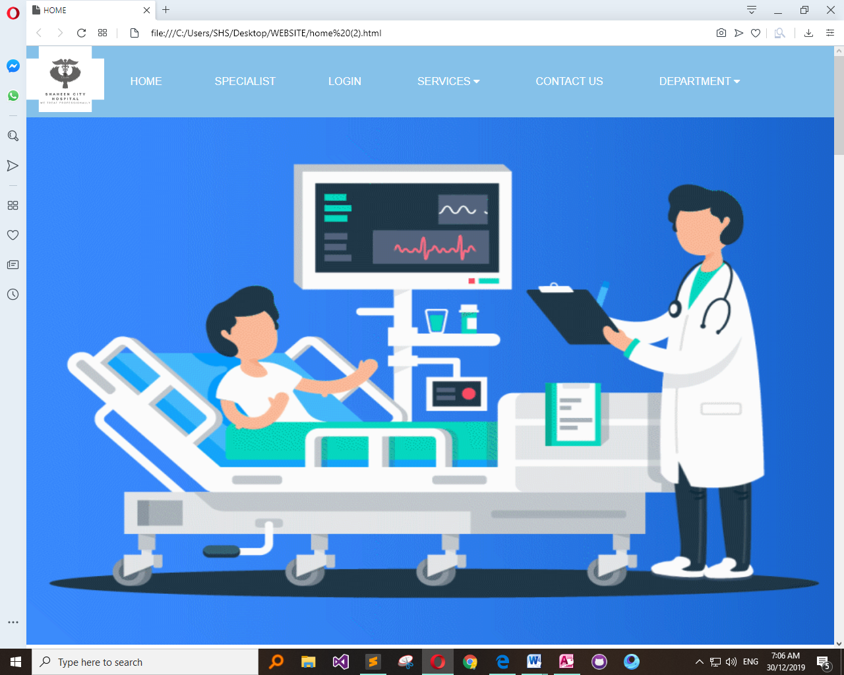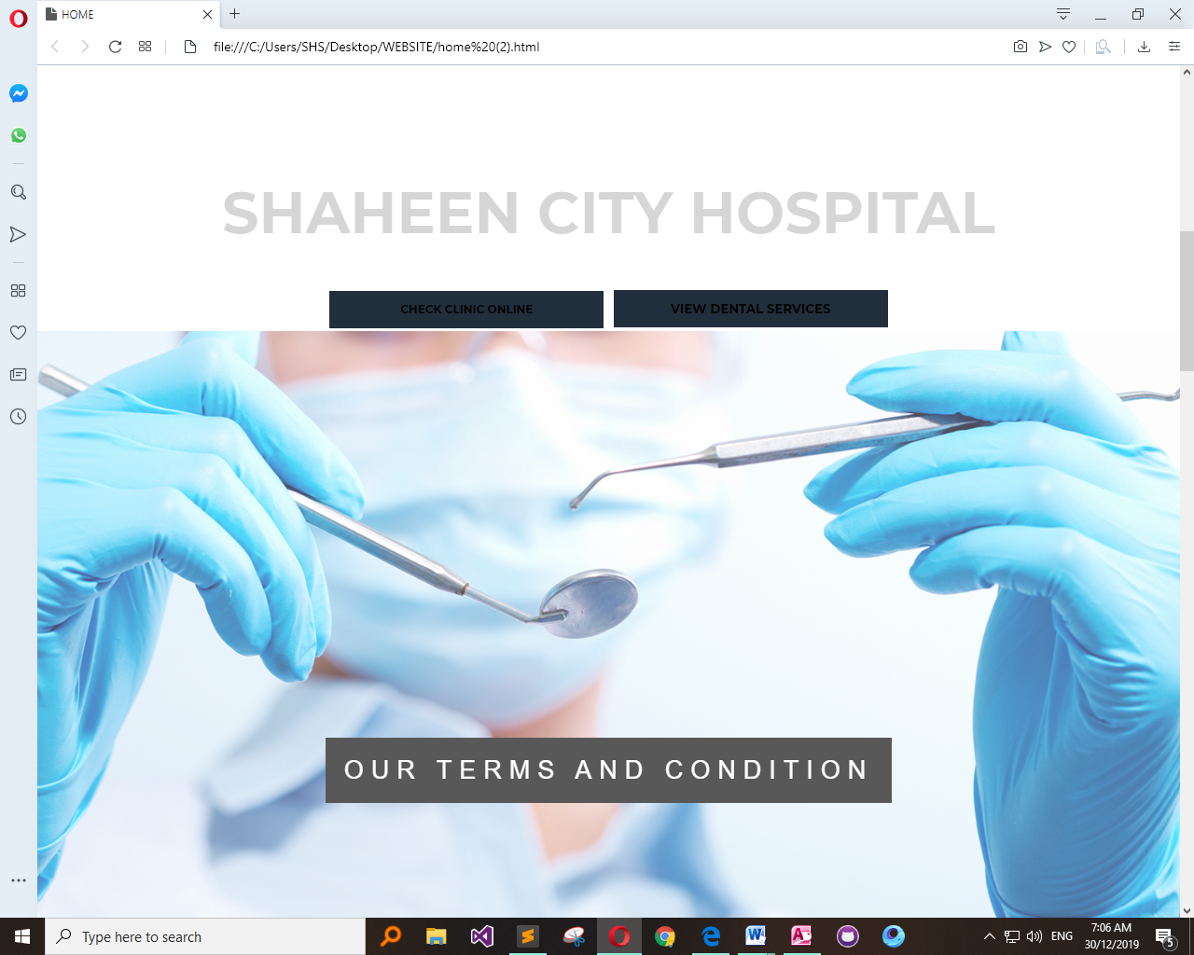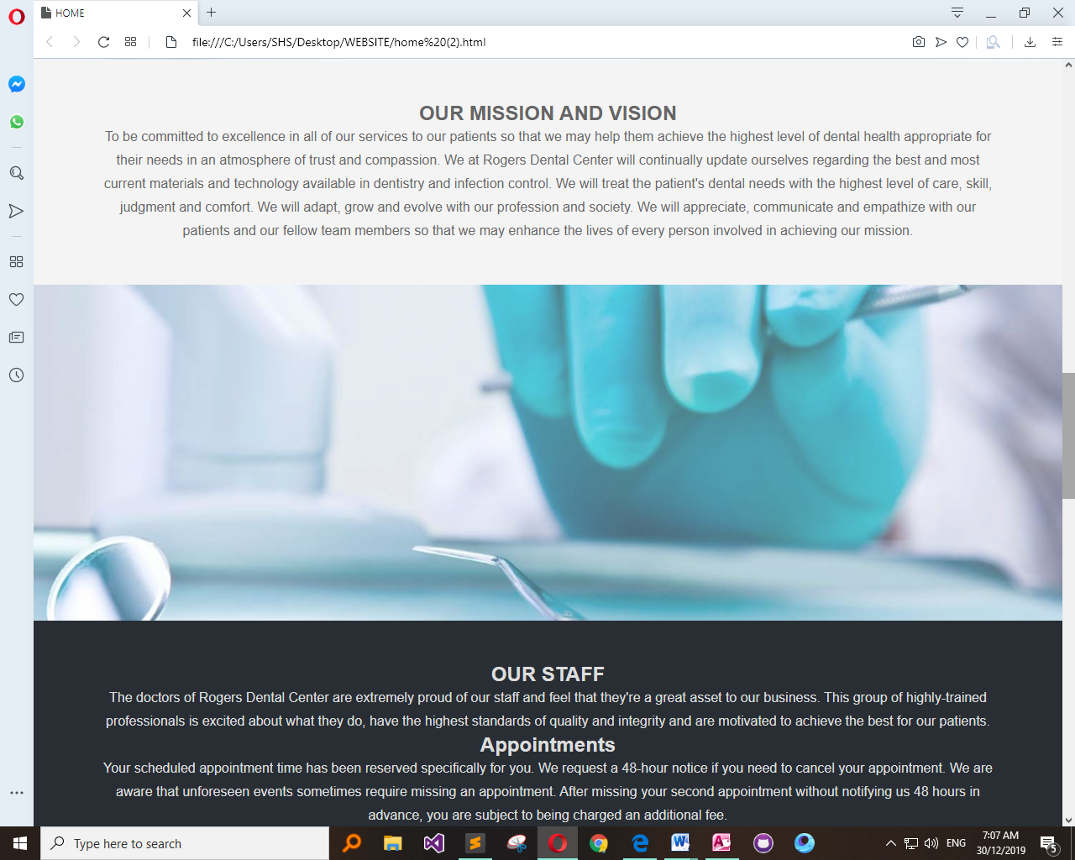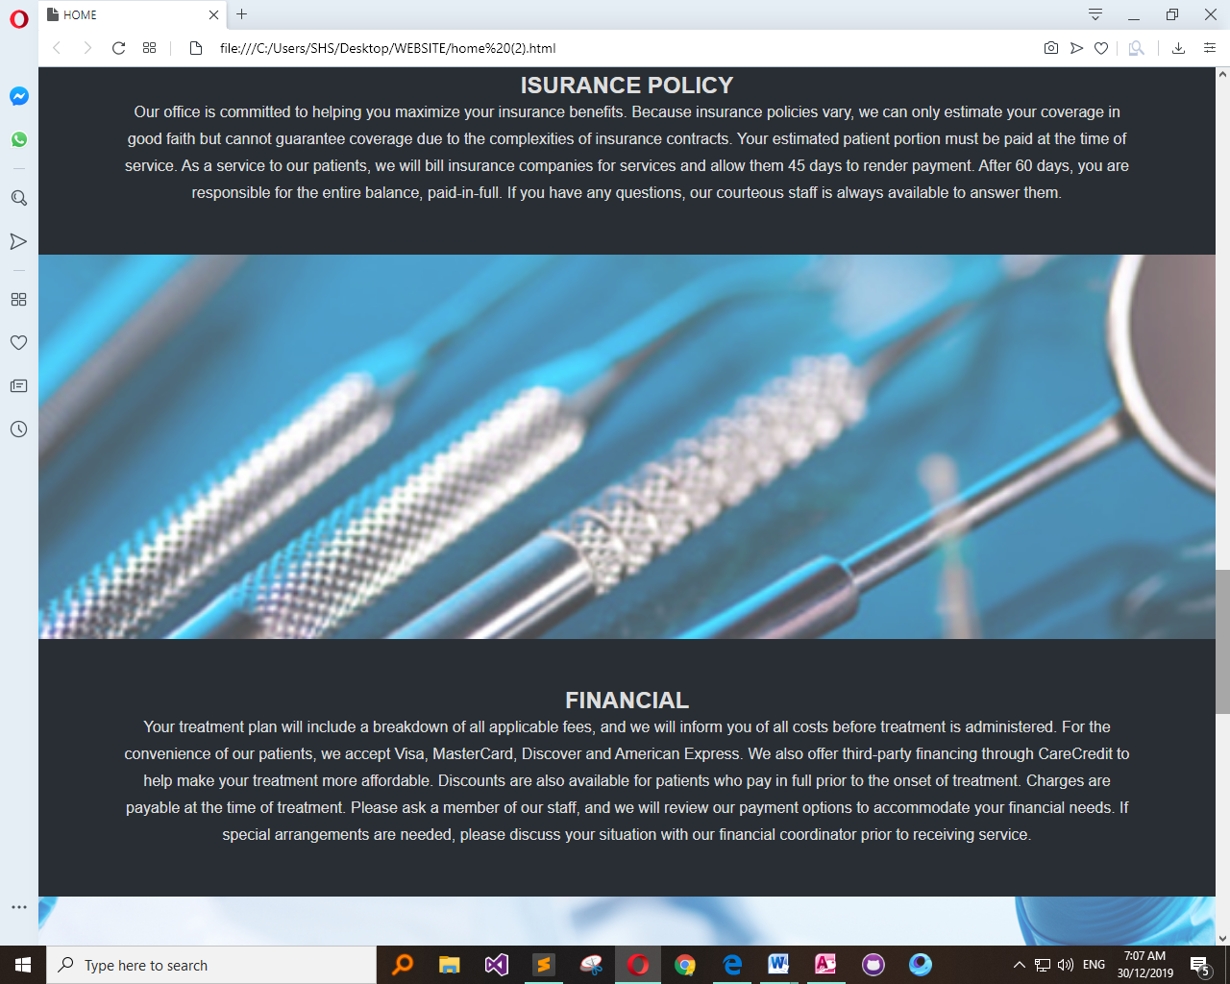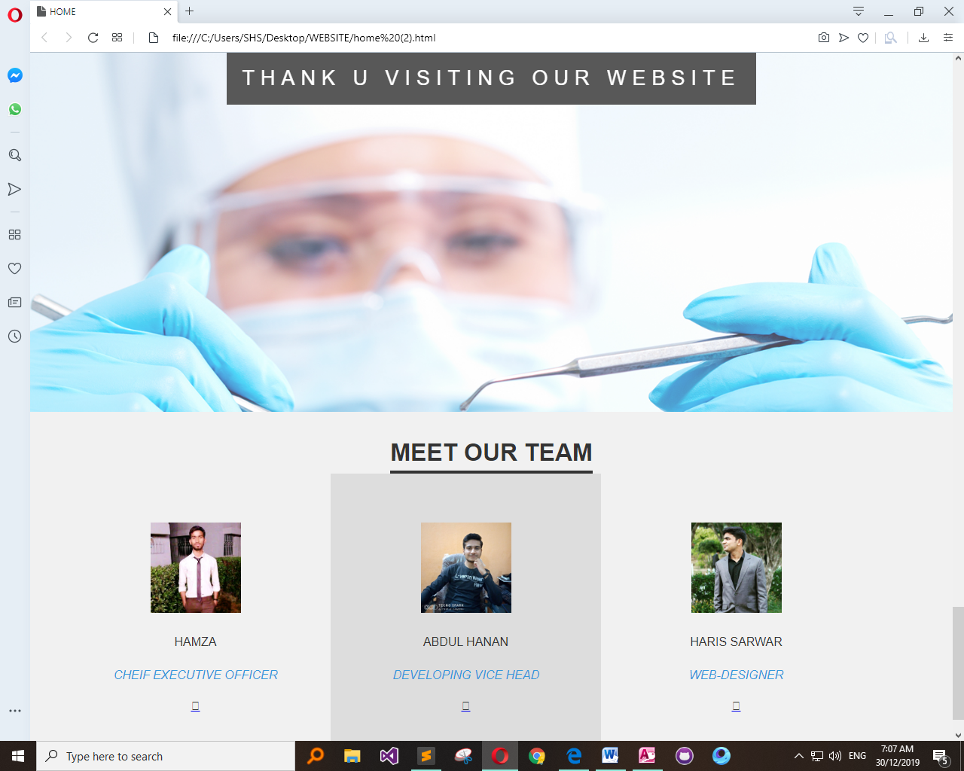

Specialist Page:

<!DOCTYPE html>

<html>

<head>

<title></title>

<link rel="stylesheet" type="text/css" href="style.css">

<link href='http://fonts.googleapis.com/css?family=Montserrat:400,700%7CPT+Serif:400,700,400italic' rel='stylesheet'>

<link href="https://fonts.googleapis.com/css?family=Montserrat|Open+Sans" rel="stylesheet">

</head>

<style type="text/css">

*{

margin:0px;

padding:0px;

}

.bgimage{

background-image: url('d2.jpg');

background-size: 100% 110%;

width: 100%;

height: 100vh;

}

.menu{

width: 100%;

height: 150px;

background-color:#5DADE2;

}

.leftmenu{

width: 30%;

line-height: 0px;

float: left;

/* background-color: yellow;*/

}

.leftmenu h4{

padding-left: 50px;

font-weight: bold;

color: white;

font-size: 25px;

font-family: 'Montserrat', sans-serif;

}

.rightmenu{

line-height: 200px;

width:70%;

height: 100px;

float: right;

/* background-color: red; */

}

.rightmenu ul{

margin-left: 100px;

}

.rightmenu ul li {

float: left;

font-family: 'Montserrat', sans-serif;

display: inline-block;

list-style: none;

font-size: 15px;

color:white;

font-weight: bold;

line-height: 200px;

margin-left: 20px;

text-transform: uppercase;

}

#fisrtlist{

color: orange;

}

.rightmenu ul li:hover{

color: orange;

}

.text{

width: 100%;

margin-top: 185px;

text-transform: uppercase;

text-align: center;

color:white;

}

.text h4{

font-size: 14px;

font-family: 'Open Sans', sans-serif;

}

.text h1{

font-size:62px;

font-family: 'Montserrat', sans-serif;

font-weight: 700px;

margin:14px 0px;

animation: 1.5s;

color: #3333 ;

}

.buttonone{

background-color: #212F3C;

border: none;

font-size: 12px;

font-weight: bold;

text-transform: uppercase;

line-height: 40px;

width: 300px;

font-family: 'Montserrat', sans-serif;

margin-top: 25px;

border: 3px solid white;

}

.buttonone:hover{

color: orange;

background-color: rgb(97, 106, 107);

}

.buttontwo{

background-color: #212F3C;

border: none;

font-family: 'Montserrat', sans-serif;

text-transform: uppercase;

font-weight: bold;

line-height: 40px;

border: 3px solid white;

width: 300px;

}

.buttontwo:hover{

color: orange;

background-color: rgb(97, 106, 107);

}

.navimg{

padding-left: 0px;

}

body{

margin: 0;

padding: 0;

font-family: "montserrat";

}

.team-section{

background: #f1f1f1;

text-align: center;

}

.inner-width{

max-width: 1200px;

margin: auto;

padding: 40px;

color: #333;

overflow: hidden;

}

.team-section h1{

font-size: 15px 0;

text-transform: uppercase;

display: inline-block;

border-bottom: 4px solid;

padding-bottom: 10px;

}

.pe{

float: left;

width: calc(100% / 5);

overflow: hidden;

padding: 65PX;

transition: 0.4s;

}

.pe:hover{

background: #ddd;

}

.pe img{

width: 120px;

height: 120px;

}

.p-name{

margin: 16px 0;

text-transform: uppercase;

}

.p-des{

font-style: italic;

color: #3498db;

}

.p-sm{

margin-top: 12px;

}

.p-sm a{

margin: 0 4px;

display: inline-block;

width: 30px;

height: 30px;

transition: 0.4s;

}

.p-sm a:hover{

transform: scale(1.3);

}

.p-sm a i{

color: #333;

line-height: 30px;

}

@media screen and (max-width:600px) {

.pe{

width: 100%;

}

}

body, html{

height:100%;

margin:0;

font-size:16px;

font-family:"Lato", sans-serif;

font-weight:400;

line-height:1.8em;

color:#666;

}

.pimg1, .pimg2, .pimg3{

position:relative;

opacity:0.70;

background-position:center;

background-size:cover;

background-repeat:no-repeat;

/*

fixed = parallax

scroll = normal

*/

background-attachment:fixed;

}

.pimg1{

background-image:url('32.jpg');

min-height:100%;

}

.pimg2{

background-image:url('31.jpg');

min-height:400px;

}

.pimg3{

background-image:url('39.png');

min-height:400px;

}

.section{

text-align:center;

padding:50px 80px;

}

.section-light{

background-color:#f4f4f4;

color:#666;

}

.section-dark{

background-color:#282e34;

color:#ddd;

}

.ptext{

position:absolute;

top:50%;

width:100%;

text-align:center;

color:#000;

font-size:27px;

letter-spacing:8px;

text-transform:uppercase;

}

.ptext .border{

background-color:#111;

color:#fff;

padding:20px;

}

.ptext .border.trans{

background-color:transparent;

}

@media(max-width:568px){

.pimg1, .pimg2, .pimg3{

background-attachment:scroll;

}

}

</style>

<body>

<link rel="stylesheet" href="https://cdnjs.cloudflare.com/ajax/libs/font-awesome/4.7.0/css/font-awesome.min.css">

<style>

body {

font-family: Arial, Helvetica, sans-serif;

}

.navbar {

overflow: hidden;

background-color: #85C1E9 ;

}

.navbar a {

float: left;

font-size: 16px;

color: white;

text-align: center;

padding: 40px;

text-decoration: none;

border-radius: 20px;

}

.dropdown {

float: left;

overflow: hidden;

border-radius: 20px;

}

.dropdown .dropbtn {

font-size: 16px;

border: none;

outline: none;

color: white;

padding: 45px;

background-color: inherit;

font-family: inherit;

margin: 0;

border-radius: 20;

}

.navbar a:hover, .dropdown:hover .dropbtn {

background-color: #E59866 ;

border-radius: 20;

}

.dropdown-content {

display: none;

position: absolute;

background-color: #f9f9f9;

min-width: 160px;

box-shadow: 0px 8px 16px 0px rgba(0,0,0,0.2);

z-index: 1;

border-radius: 20px;

}

.dropdown-content a {

float: none;

color: black;

padding: 12px 16px;

text-decoration: none;

display: block;

text-align: left;

border-radius: 20px;

}

.dropdown-content a:hover {

background-color: #E59866;

border-radius: 20;

}

.dropdown:hover .dropdown-content {

display: block;

border-radius: 20;

}

}

</style>

</style>

</head>

<body>

<div class="navbar">

<img src="LOGO HOSPITAL.png" alt="shaheen city hospital logo"style="float:left; height: 100px;" >

<a href="home.html">HOME</a>

<a href="specialist.html">SPECIALIST</a>

<a href="login.html">LOGIN</a>

<div class="dropdown">

<button class="dropbtn">SERVICES

<i class="fa fa-caret-down"></i>

</button>

<div class="dropdown-content">

<a href="CLINICAL NUTRITION & CAFETERIA.html">CLINICAL NUTRITION & CAFETERIA</a>

<a href="EMERGENCY CARE.html">EMERGENCY CARE</a>

<a href="CANCER CENTER.html">CANCER CENTER</a>

<a href="CARDIOLOGY.html">CARDIOLOGY</a>

<a href="FINANCIAL HELP.html">FINANCIAL HELP TO NEEDY PEOPLE </a>

</div>

</div>

<a href="contact.html">CONTACT US</a>

<div class="dropdown">

<button class="dropbtn">DEPARTMENT

<i class="fa fa-caret-down"></i>

</button>

<div class="dropdown-content">

<a href="ent.html">ENT</a>

<a href="opd.html">OPD</a>

<a href="CARDIO.html">CARDIO</a>

<a href="skin.html">SKIN </a>

</div>

</div>

</div>

</div>

<div class="div img">

<img src="hospital.gif" height="400px" width="100%">

</div>

<div class="text">

<h4> EXCELLENCE IN HEALTH CARE </h4>

<h1> SHAHEEN CITY HOSPITAL </h1>

<h3> WE HAVE THE BEST DOCTORS TO SERVE OUR PATEINTS </h3>

</div>

</div>

</body>

<section class="section section-light">

<h2>ENT</h2>

<p>

At Shaheen City Hospital our Ear, Nose and Throat (ENT) consultants provide a variety of services on par with international standards. Our ENT consultants utilize state-of-the-art microscopes, fiber-optic laryngoscope with video recording options, as well as rigid nasal and ear endoscopes. All the instruments we use are thoroughly sterilized keeping in mind the high incidence of Hepatitis C in Pakistan.

</p>

<h2>OPD</h2>

<p>

Shaheen City Hospital’s Orthopaedic and Spine Center provides a comprehensive program for patients who experience degenerative and acute joint, back and neck conditions as a result of trauma, illness or aging. The Orthopaedic and Spine Center’s combination of patient education, individualized care, advanced treatment, and reconstruction options ensures that patients achieve the highest level of independence and physical function. Our doctors are leaders in their specialty areas, providing state-of-the-art treatment and care in the diagnosis, treatment and rehabilitation of orthopaedic conditions to patients of all ages, helping to shorten the hospital stay and recovery time. Shaheen City Hospital offers a full range of orthopaedic surgical services, with several areas of special expertise.

</p>

<h2>CARDIOLOGY</h2>

<p>

The Cardiology Department at Shaheen City Hospital offers a full spectrum of specialty services for patients with conditions that affect their heart and blood vessels. Our goal is to provide exceptional care for patients at risk for or with established cardiovascular disease. We also aim to educate future leaders in cardiovascular medicine.

</p>

<h2>SKIN</h2>

<p>

Dermatology specializes in the largest organ in the human body – the skin. We offer expertise in the management of both common and rare skin diseases. Dermatology seeks to improve the quality of life for patients suffering from the pain, frustration and potential embarrassment that can be caused by skin diseases.

</p>

</section>

<div class="pimg1">

<div class="ptext">

<span class="border">

THANK U VISITING OUR WEBSITE

</span>

</div>

</div>

</body>

<footer>

<div class="team-section">

<div class="inner-width">

<h1>Meet Our Team</h1>

<div class="pers">

<div class="pe">

<img src="H1.jpg" alt="HAMZA">

<div class="p-name">HAMZA</div>

<div class="p-des">CHEIF EXECUTIVE OFFICER</div>

<div class="p-sm">

<a href="#"><i class="fab fa-facebook-f"></i></a>

</div>

</div>

<div class="pe">

<img src="H2.jpeg" alt="HANAN">

<div class="p-name">ABDUL HANAN</div>

<div class="p-des">DEVELOPING VICE HEAD</div>

<div class="p-sm">

<a href="#"><i class="fab fa-facebook-f"></i></a>

</div>

</div>

</div><div class="pe">

<img src="H3.jpg" alt="HARIS">

<div class="p-name">HARIS SARWAR</div>

<div class="p-des">WEB-DESIGNER</div>

<div class="p-sm">

<a href="#"><i class="fab fa-facebook-f"></i></a>

</div>

</div>

</div>

</div>

</footer>

</html>

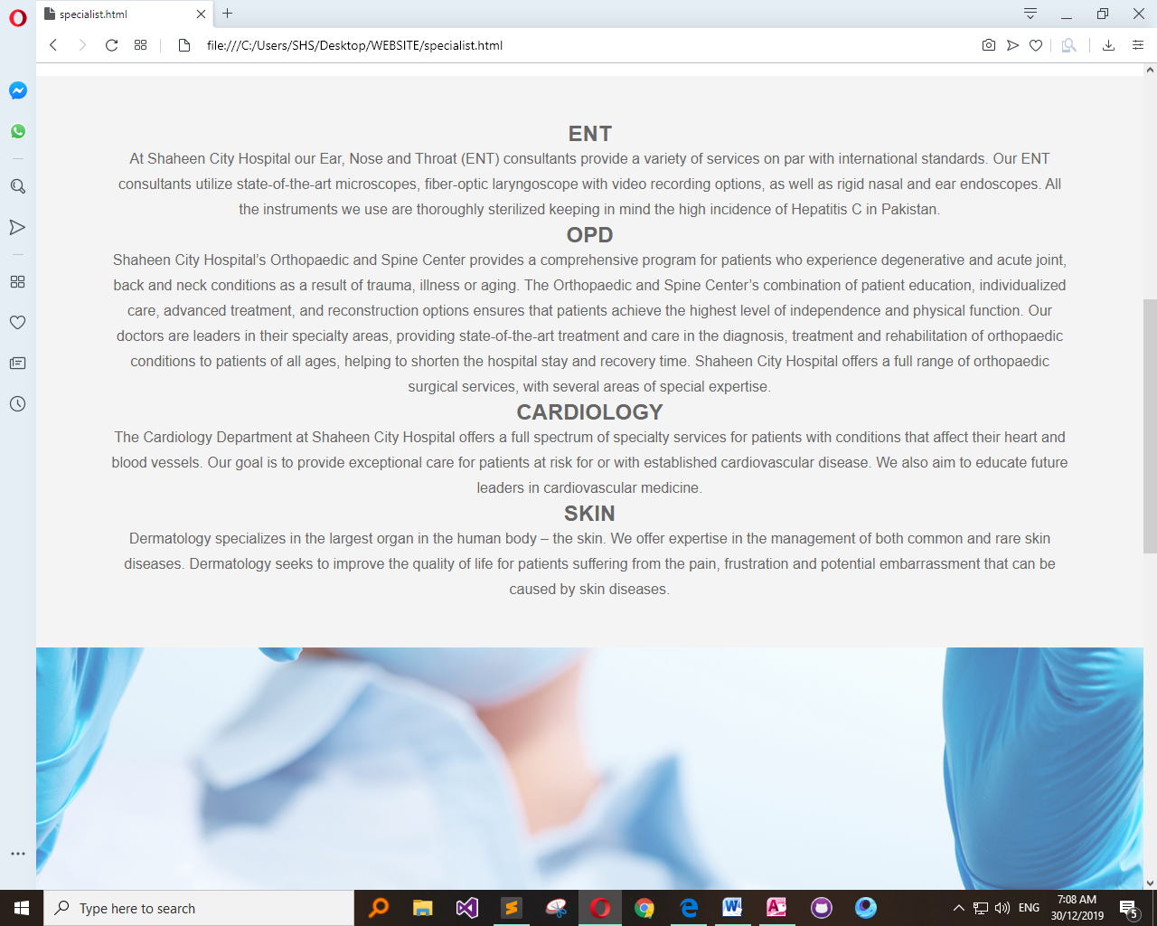

Login Page:

<!DOCTYPE html>

<html lang="en" dir="ltr">

<head>

<meta charset="utf-8">

<title></title>

<link rel="stylesheet" href="style.css">

<script src="https://cdnjs.cloudflare.com/ajax/libs/jquery/3.4.1/jquery.min.js" charset="utf-8"></script>

</head>

<style type="text/css">

*{

margin: 0;

padding: 0;

text-decoration: none;

font-family: Arial, Helvetica, sans-serif;

box-sizing: border-box;

}

body{

min-height: 100vh;

background-image: linear-gradient(120deg,#3498db,#8e44ad);

}

.login-form{

width: 360px;

background: #f1f1f1;

height: 580px;

padding: 80px 40px;

border-radius: 10px;

position: absolute;

left: 50%;

top: 50%;

transform: translate(-50%,-50%);

}

.login-form h1{

text-align: center;

margin-bottom: 60px;

}

.txtb{

border-bottom: 2px solid #adadad;

position: relative;

margin: 30px ;

}

.txtb input{

font-size: 15px;

color: #9ff5f5;

border: none;

width: 100%;

outline: none;

background: none;

padding: 0 5px;

height: 40px;

}

.txtb span::before{

content: attr(data-placeholder);

position: absolute;

top: 50%;

left: 5px;

color: #adadad;

transform: translateY(-50%);

z-index: -1;

transition: .5s;

}

.txtb span::after{

content: '';

position: absolute;

width: 0%;

height: 2px;

background: linear-gradient(120deg,#3498db,#8e44ad);

transition: .5s;

}

.focus + span::before{

top: -5px;

}

.focus + span::after{

width: 100%;

}

.logbtn{

display: block;

width: 100%;

height: 50px;

border: none;

background: linear-gradient(120deg,#3498db,#8e44ad,#3498db);

background-size: 200%;

color: #fff;

outline: none;

cursor: pointer;

transition: .5s;

}

.logbtn:hover{

background-position: right;

}

.bottom-text{

margin-top: 60px;

text-align: center;

font-size: 13px;

}

</style>

<body>

<link rel="stylesheet" href="https://cdnjs.cloudflare.com/ajax/libs/font-awesome/4.7.0/css/font-awesome.min.css">

<style>

body {

font-family: Arial, Helvetica, sans-serif;

}

.navbar {

overflow: hidden;

background-color: #85C1E9 ;

}

.navbar a {

float: left;

font-size: 16px;

color: white;

text-align: center;

padding: 45px;

text-decoration: none;

border-radius: 20px;

}

.dropdown {

float: left;

overflow: hidden;

border-radius: 20px;

}

.dropdown .dropbtn {

font-size: 16px;

border: none;

outline: none;

color: white;

padding: 45px;

background-color: inherit;

font-family: inherit;

margin: 0;

border-radius: 20;

}

.navbar a:hover, .dropdown:hover .dropbtn {

background-color: #E59866 ;

border-radius: 20;

}

.dropdown-content {

display: none;

position: absolute;

background-color: #f9f9f9;

min-width: 160px;

box-shadow: 0px 8px 16px 0px rgba(0,0,0,0.2);

z-index: 1;

border-radius: 20px;

}

.dropdown-content a {

float: none;

color: black;

padding: 12px 16px;

text-decoration: none;

display: block;

text-align: left;

border-radius: 20px;

}

.dropdown-content a:hover {

background-color: #E59866;

border-radius: 20;

}

.dropdown:hover .dropdown-content {

display: block;

border-radius: 20;

}

}

</style>

</style>

</head>

<body>

<div class="navbar">

<img src="LOGO HOSPITAL.png" alt="shaheen city hospital logo"style="float:left; height: 100px;" >

<a href="home.html">HOME</a>

<a href="specialist.html">SPECIALIST</a>

<a href="login.html">LOGIN</a>

<div class="dropdown">

<button class="dropbtn">SERVICES

<i class="fa fa-caret-down"></i>

</button>

<div class="dropdown-content">

<a href="CLINICAL NUTRITION & CAFETERIA.html">CLINICAL NUTRITION & CAFETERIA</a>

<a href="EMERGENCY CARE.html">EMERGENCY CARE</a>

<a href="CANCER CENTER.html">CANCER CENTER</a>

<a href="CARDIOLOGY.html">CARDIOLOGY</a>

<a href="FINANCIAL HELP.html">FINANCIAL HELP TO NEEDY PEOPLE </a>

</div>

</div>

<a href="contact.html">CONTACT US</a>

<div class="dropdown">

<button class="dropbtn">DEPARTMENT

<i class="fa fa-caret-down"></i>

</button>

<div class="dropdown-content">

<a href="ent.html">ENT</a>

<a href="opd.html">OPD</a>

<a href="CARDIO.html">CARDIO</a>

<a href="skin.html">SKIN </a>

</div>

</div>

</div>

</div>

<form action="index.html" class="login-form">

<h1>Login</h1>

<div class="txtb">

<input type="text">

<span data-placeholder="Username"></span>

</div>

<div class="txtb">

<input type="password">

<span data-placeholder="Password"></span>

</div>

<input type="submit" class="logbtn" value="Login">

<div class="bottom-text">

Don't have account? <a href="#">Sign up</a>

</div>

</form>

<script type="text/javascript">

$(".txtb input").on("focus",function(){

$(this).addClass("focus");

});

$(".txtb input").on("blur",function(){

if($(this).val() == "")

$(this).removeClass("focus");

});

</script>

</body>

</html>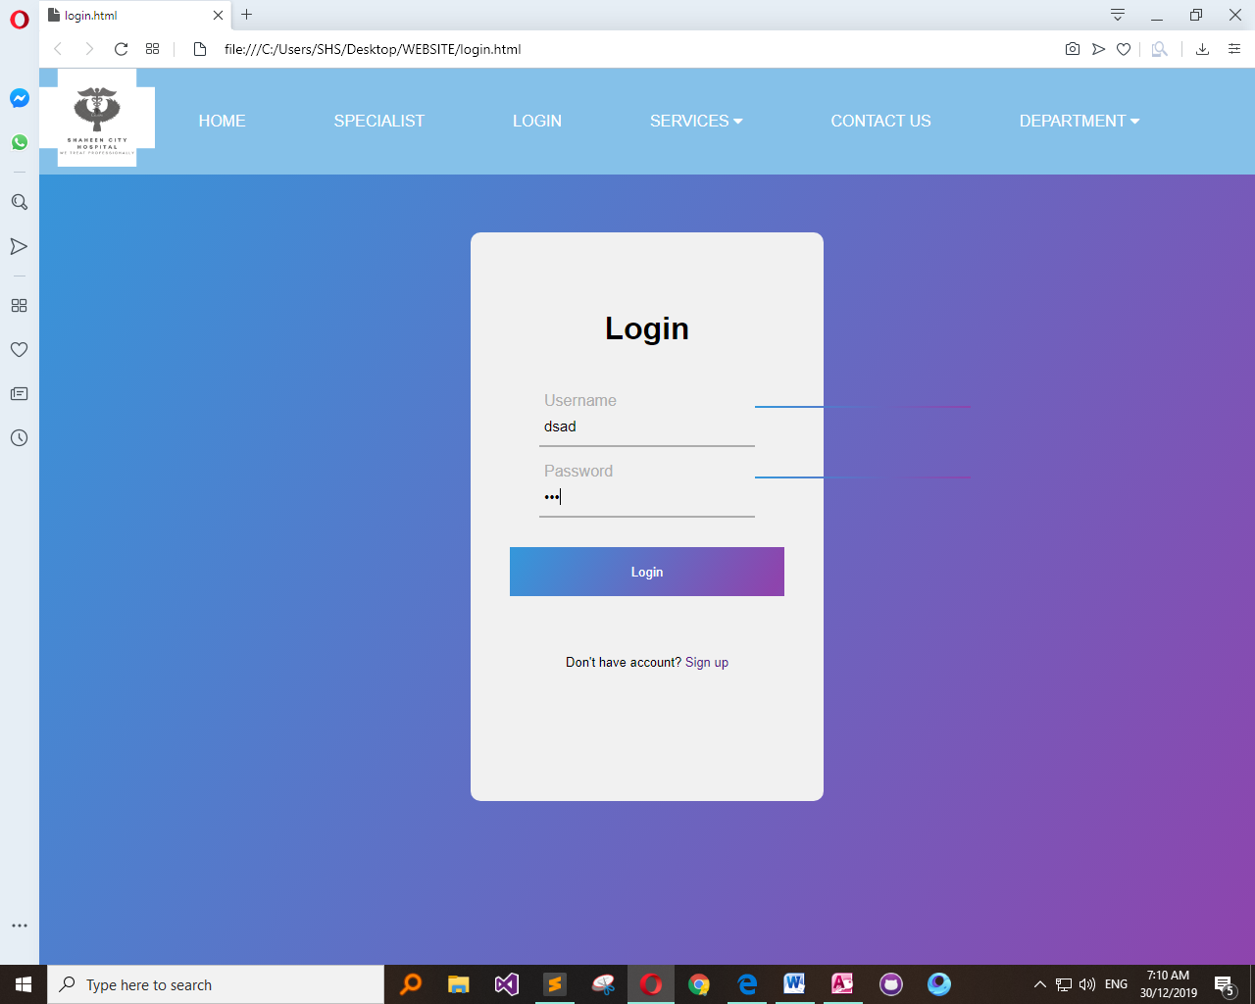

Services Page:

<!DOCTYPE html>

<html>

<head>

<title>CLINICAL NUTRITION & CAFETERIA</title>

<link rel="stylesheet" type="text/css" href="style.css">

<link href='http://fonts.googleapis.com/css?family=Montserrat:400,700%7CPT+Serif:400,700,400italic' rel='stylesheet'>

<link href="https://fonts.googleapis.com/css?family=Montserrat|Open+Sans" rel="stylesheet">

</head>

<style type="text/css">

*{

margin:0px;

padding:0px;

}

.bgimage{

background-image: url('d2.jpg');

background-size: 100% 110%;

width: 100%;

height: 100vh;

}

.menu{

width: 100%;

height: 150px;

background-color:#5DADE2;

}

.leftmenu{

width: 30%;

line-height: 0px;

float: left;

/* background-color: yellow;*/

}

.leftmenu h4{

padding-left: 50px;

font-weight: bold;

color: white;

font-size: 25px;

font-family: 'Montserrat', sans-serif;

}

.rightmenu{

line-height: 200px;

width:70%;

height: 100px;

float: right;

/* background-color: red; */

}

.rightmenu ul{

margin-left: 100px;

}

.rightmenu ul li {

float: left;

font-family: 'Montserrat', sans-serif;

display: inline-block;

list-style: none;

font-size: 15px;

color:white;

font-weight: bold;

line-height: 200px;

margin-left: 20px;

text-transform: uppercase;

}

#fisrtlist{

color: orange;

}

.rightmenu ul li:hover{

color: orange;

}

.text{

width: 100%;

margin-top: 185px;

text-transform: uppercase;

text-align: center;

color:white;

}

.text h4{

font-size: 14px;

font-family: 'Open Sans', sans-serif;

}

.text h1{

font-size:62px;

font-family: 'Montserrat', sans-serif;

font-weight: 700px;

margin:14px 0px;

animation: 1.5s;

color: #3333 ;

}

.buttonone{

background-color: #212F3C;

border: none;

font-size: 12px;

font-weight: bold;

text-transform: uppercase;

line-height: 40px;

width: 300px;

font-family: 'Montserrat', sans-serif;

margin-top: 25px;

border: 3px solid white;

}

.buttonone:hover{

color: orange;

background-color: rgb(97, 106, 107);

}

.buttontwo{

background-color: #212F3C;

border: none;

font-family: 'Montserrat', sans-serif;

text-transform: uppercase;

font-weight: bold;

line-height: 40px;

border: 3px solid white;

width: 300px;

}

.buttontwo:hover{

color: orange;

background-color: rgb(97, 106, 107);

}

.navimg{

padding-left: 0px;

}

body{

margin: 0;

padding: 0;

font-family: "montserrat";

}

.team-section{

background: #f1f1f1;

text-align: center;

}

.inner-width{

max-width: 1200px;

margin: auto;

padding: 40px;

color: #333;

overflow: hidden;

}

.team-section h1{

font-size: 15px 0;

text-transform: uppercase;

display: inline-block;

border-bottom: 4px solid;

padding-bottom: 10px;

}

.pe{

float: left;

width: calc(100% / 5);

overflow: hidden;

padding: 65PX;

transition: 0.4s;

}

.pe:hover{

background: #ddd;

}

.pe img{

width: 120px;

height: 120px;

}

.p-name{

margin: 16px 0;

text-transform: uppercase;

}

.p-des{

font-style: italic;

color: #3498db;

}

.p-sm{

margin-top: 12px;

}

.p-sm a{

margin: 0 4px;

display: inline-block;

width: 30px;

height: 30px;

transition: 0.4s;

}

.p-sm a:hover{

transform: scale(1.3);

}

.p-sm a i{

color: #333;

line-height: 30px;

}

@media screen and (max-width:600px) {

.pe{

width: 100%;

}

}

body, html{

height:100%;

margin:0;

font-size:16px;

font-family:"Lato", sans-serif;

font-weight:400;

line-height:1.8em;

color:#666;

}

.pimg1, .pimg2, .pimg3{

position:relative;

opacity:0.70;

background-position:center;

background-size:cover;

background-repeat:no-repeat;

/*

fixed = parallax

scroll = normal

*/

background-attachment:fixed;

}

.pimg1{

background-image:url('32.jpg');

min-height:100%;

}

.pimg2{

background-image:url('31.jpg');

min-height:400px;

}

.pimg3{

background-image:url('39.png');

min-height:400px;

}

.section{

text-align:center;

padding:50px 80px;

}

.section-light{

background-color:#f4f4f4;

color:#666;

}

.section-dark{

background-color:#282e34;

color:#ddd;

}

.ptext{

position:absolute;

top:50%;

width:100%;

text-align:center;

color:#000;

font-size:27px;

letter-spacing:8px;

text-transform:uppercase;

}

.ptext .border{

background-color:#111;

color:#fff;

padding:20px;

}

.ptext .border.trans{

background-color:transparent;

}

@media(max-width:568px){

.pimg1, .pimg2, .pimg3{

background-attachment:scroll;

}

}

</style>

<body>

<link rel="stylesheet" href="https://cdnjs.cloudflare.com/ajax/libs/font-awesome/4.7.0/css/font-awesome.min.css">

<style>

body {

font-family: Arial, Helvetica, sans-serif;

}

.navbar {

overflow: hidden;

background-color: #85C1E9 ;

}

.navbar a {

float: left;

font-size: 16px;

color: white;

text-align: center;

padding: 40px;

text-decoration: none;

border-radius: 20px;

}

.dropdown {

float: left;

overflow: hidden;

border-radius: 20px;

}

.dropdown .dropbtn {

font-size: 16px;

border: none;

outline: none;

color: white;

padding: 45px;

background-color: inherit;

font-family: inherit;

margin: 0;

border-radius: 20;

}

.navbar a:hover, .dropdown:hover .dropbtn {

background-color: #E59866 ;

border-radius: 20;

}

.dropdown-content {

display: none;

position: absolute;

background-color: #f9f9f9;

min-width: 160px;

box-shadow: 0px 8px 16px 0px rgba(0,0,0,0.2);

z-index: 1;

border-radius: 20px;

}

.dropdown-content a {

float: none;

color: black;

padding: 12px 16px;

text-decoration: none;

display: block;

text-align: left;

border-radius: 20px;

}

.dropdown-content a:hover {

background-color: #E59866;

border-radius: 20;

}

.dropdown:hover .dropdown-content {

display: block;

border-radius: 20;

}

}

</style>

</style>

</head>

<body>

<div class="navbar">

<img src="LOGO HOSPITAL.png" alt="shaheen city hospital logo"style="float:left; height: 100px;" >

<a href="home.html">HOME</a>

<a href="specialist.html">SPECIALIST</a>

<a href="login.html">LOGIN</a>

<div class="dropdown">

<button class="dropbtn">SERVICES

<i class="fa fa-caret-down"></i>

</button>

<div class="dropdown-content">

<a href="CLINICAL NUTRITION & CAFETERIA.html">CLINICAL NUTRITION & CAFETERIA</a>

<a href="EMERGENCY CARE.html">EMERGENCY CARE</a>

<a href="CANCER CENTER.html">CANCER CENTER</a>

<a href="CARDIOLOGY.html">CARDIOLOGY</a>

<a href="FINANCIAL HELP.html">FINANCIAL HELP TO NEEDY PEOPLE </a>

</div>

</div>

<a href="contact.html">CONTACT US</a>

<div class="dropdown">

<button class="dropbtn">DEPARTMENT

<i class="fa fa-caret-down"></i>

</button>

<div class="dropdown-content">

<a href="ent.html">ENT</a>

<a href="opd.html">OPD</a>

<a href="CARDIO.html">CARDIO</a>

<a href="skin.html">SKIN </a>

</div>

</div>

</div>

</div>

<div class="div img">

<img src="hospital.gif" height="400px" width="100%">

</div>

<div class="text">

<h4> EXCELLENCE IN HEALTH CARE </h4>

<h1> SHAHEEN CITY HOSPITAL </h1>

</div>

</div>

</body>

<body>

<section class="section section-light">

<img src="C:\Users\SHS\Desktop\WEBSITE\cafe.jpg" height="400px" width="500px">

<h2>CLINICAL NUTRITION</h2>

<p>

This specialized nutrition care department in Shaheen City Hospital and Medical Center offers nutrition care counseling to the patients in the best possible way by the experienced Clinical Nutritionist Ms. Ayesha khan whose expertise has a foundation on trustworthy, science based nutritional information as well as vast experience in the pertinent field.

The approach is holistic and personalized, catering to the individualized needs of the patient and the goal is to promote individualized medical nutrition therapy in a multidisciplinary approach as a means to optimize patient care.

The scope of Clinical Nutrition offered at Shaheen City Hospital covers the following areas:

Weight management,

Cardio vascular problems,

Neurological disorder,

Renal disorder,

Disorders of Gastrointestinal,

Liver disorders,

Diabetes,

Diet in various metabolic disorders,

Enteral and parenteral nutrition,

Healthy nutritional counseling for normal individuals through different life cycles.

We see the dignity of each patient along with their unique nutritional needs hence they are counseled that way. Our qualified and eminent dietitian provides outpatient services in her clinic Monday to Saturday. Inpatient services on referrals are also available to the patients who are hospitalized by our qualified clinical nutritionist.

</p>

<h2>Cafeteria</h2>

<p>The cafeteria at Shaheen City Hospital provides a wide variety of dining options for admitted patients as well as families – tailored to the dietary needs of our patients. The cafeteria is located on the ground floor and is open 24 hours and 7 days a week.

The menu includes a variety of beverages, snacks, baked goods as well as main course meals. Main course meals fall under the following categories:

Vegetable dishes,

Daal (lentil) dishes,

Chicken dishes,

Rice dishes,

Roast dishes.</p>

</section>

<div class="pimg1">

<div class="ptext">

<span class="border">

THANK U VISITING OUR WEBSITE

</span>

</div>

</div>

</body>

<footer>

<div class="team-section">

<div class="inner-width">

<h1>Meet Our Team</h1>

<div class="pers">

<div class="pe">

<img src="H1.jpg" alt="HAMZA">

<div class="p-name">HAMZA</div>

<div class="p-des">CHEIF EXECUTIVE OFFICER</div>

<div class="p-sm">

<a href="#"><i class="fab fa-facebook-f"></i></a>

</div>

</div>

<div class="pe">

<img src="H2.jpeg" alt="HANAN">

<div class="p-name">ABDUL HANAN</div>

<div class="p-des">DEVELOPING VICE HEAD</div>

<div class="p-sm">

<a href="#"><i class="fab fa-facebook-f"></i></a>

</div>

</div>

</div><div class="pe">

<img src="H3.jpg" alt="HARIS">

<div class="p-name">HARIS SARWAR</div>

<div class="p-des">WEB-DESIGNER</div>

<div class="p-sm">

<a href="#"><i class="fab fa-facebook-f"></i></a>

</div>

</div>

</div>

</div>

</footer>

</html>

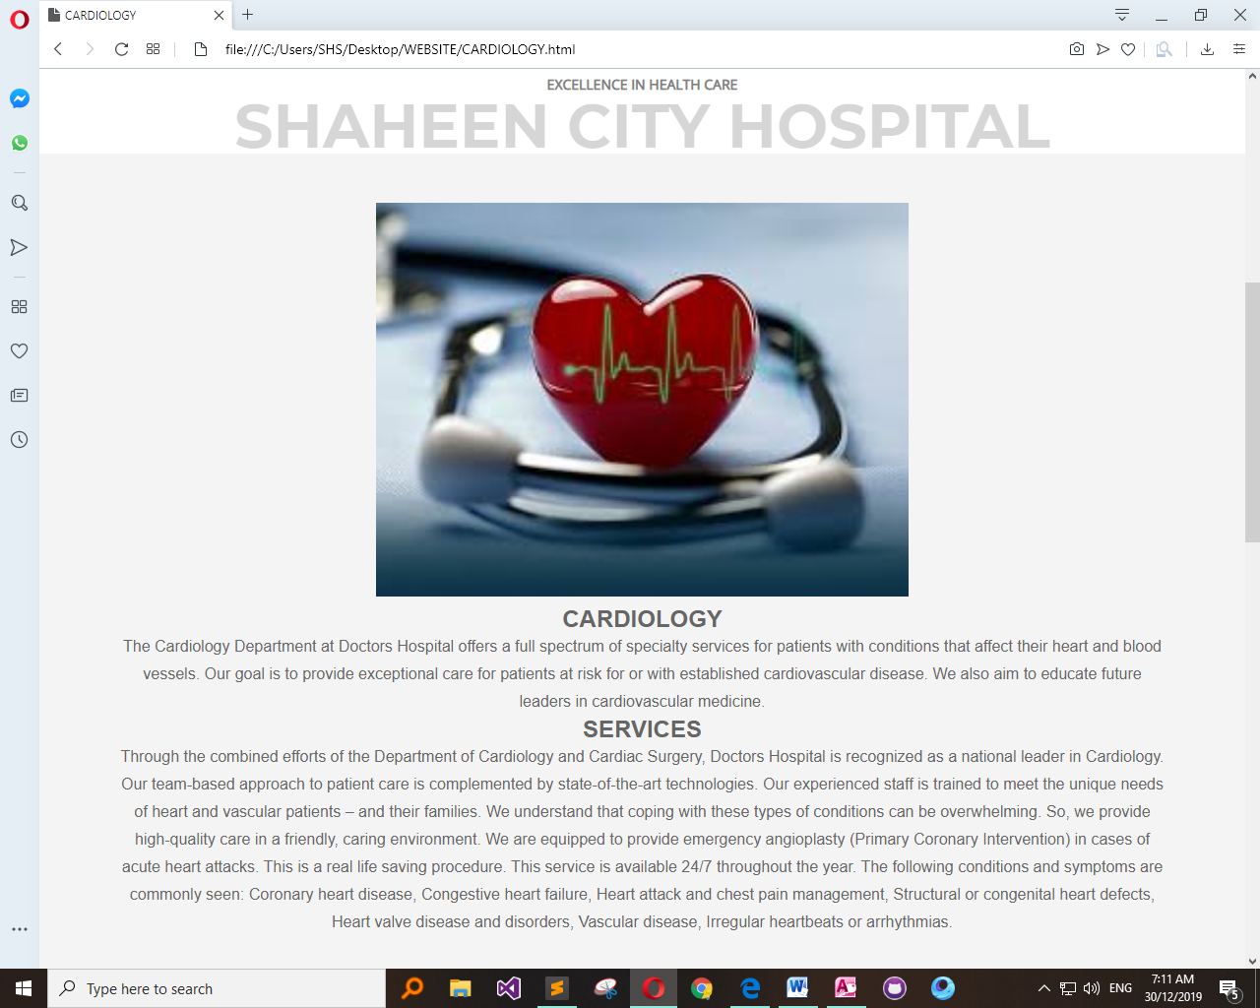

Contact Page:

<!DOCTYPE html>

<html lang="en" dir="ltr">

<head>

<meta charset="utf-8">

<meta name="viewport" content="width=device-width, initial-scale=1">

<title></title>

<link rel="stylesheet" href="style.css">

<meta name="viewport" content="width=device-width, initial-scale=1">

</head>

<style type="text/css">

body{

background-image: url(cont.jpg);

background-size: 100%;

}

*{

margin: 0;

padding: 0;

font-family: "montserrat",sans-serif;

}

.contact-section{

text-decoration: none;

background-size: cover;

padding: 40px ;

}

.contact-section h1{

text-align: center;

color: #ddd;

}

.border{

width: 200px;

height: 5px;

background: #34495e;

margin: 20px auto;

}

.contact-form{

max-width: 600px;

margin: auto;

padding: 0 10px;

overflow: hidden;

}

.contact-form-text{

display: block;

width: 100%;

box-sizing: border-box;

margin: 16px 0;

border: 0;

background: #106782;

padding: 20px 40px;

outline: none;

color: #0ee6a8;

transition: 0.5s;

border-radius: 10px;

}

.contact-form-text:focus{

box-shadow: 0 0 10px 4px #0ee6a8;

}

textarea.contact-form-text{

resize: none;

height: 120px;

}

.contact-form-btn{

float: right;

border: 0;

background: #34495e;

color: #fff;

padding: 12px 50px;

border-radius: 20px;

cursor: pointer;

transition: 0.5s;

}

.contact-form-btn:hover{

background: #22ab90;

color: #22ab90;

}

</style>

<meta name="viewport" content="width=device-width, initial-scale=1">

<link rel="stylesheet" href="https://cdnjs.cloudflare.com/ajax/libs/font-awesome/4.7.0/css/font-awesome.min.css">

<style>

<body>

<link rel="stylesheet" href="https://cdnjs.cloudflare.com/ajax/libs/font-awesome/4.7.0/css/font-awesome.min.css">

<style>

body {

font-family: Arial, Helvetica, sans-serif;

}

.navbar {

overflow: hidden;

background-color: #85C1E9 ;

}

.navbar a {

float: left;

font-size: 16px;

color: white;

text-align: center;

padding: 45px;

text-decoration: none;

border-radius: 20px;

}

.dropdown {

float: left;

overflow: hidden;

border-radius: 20px;

}

.dropdown .dropbtn {

font-size: 16px;

border: none;

outline: none;

color: white;

padding: 45px;

background-color: inherit;

font-family: inherit;

margin: 0;

border-radius: 20;

}

.navbar a:hover, .dropdown:hover .dropbtn {

background-color: #E59866 ;

border-radius: 20;

}

.dropdown-content {

display: none;

position: absolute;

background-color: #f9f9f9;

min-width: 160px;

box-shadow: 0px 8px 16px 0px rgba(0,0,0,0.2);

z-index: 1;

border-radius: 20px;

}

.dropdown-content a {

float: none;

color: black;

padding: 12px 16px;

text-decoration: none;

display: block;

text-align: left;

border-radius: 20px;

}

.dropdown-content a:hover {

background-color: #E59866;

border-radius: 20;

}

.dropdown:hover .dropdown-content {

display: block;

border-radius: 20;

}

}

</style>

</style>

</head>

<body>

<div class="navbar">

<img src="LOGO HOSPITAL.png" alt="shaheen city hospital logo"style="float:left; height: 100px;" >

<a href="home.html">HOME</a>

<a href="specialist.html">SPECIALIST</a>

<a href="login.html">LOGIN</a>

<div class="dropdown">

<button class="dropbtn">SERVICES

<i class="fa fa-caret-down"></i>

</button>

<div class="dropdown-content">

<a href="CLINICAL NUTRITION & CAFETERIA.html">CLINICAL NUTRITION & CAFETERIA</a>

<a href="EMERGENCY CARE.html">EMERGENCY CARE</a>

<a href="CANCER CENTER.html">CANCER CENTER</a>

<a href="CARDIOLOGY.html">CARDIOLOGY</a>

<a href="FINANCIAL HELP.html">FINANCIAL HELP TO NEEDY PEOPLE </a>

</div>

</div>

<a href="contact.html">CONTACT US</a>

<div class="dropdown">

<button class="dropbtn">DEPARTMENT

<i class="fa fa-caret-down"></i>

</button>

<div class="dropdown-content">

<a href="ent.html">ENT</a>

<a href="opd.html">OPD</a>

<a href="CARDIO.html">CARDIO</a>

<a href="skin.html">SKIN </a>

</div>

</div>

</div>

</div>

<body>

<div class="contact-section">

<h1>Contact Us</h1>

<div class="border"></div>

<form class="contact-form" action="index.html" method="post">

<input type="text" class="contact-form-text" placeholder="Your name">

<input type="email" class="contact-form-text" placeholder="Your email">

<input type="text" class="contact-form-text" placeholder="Your phone">

<textarea class="contact-form-text" placeholder="Your message"></textarea>

<input type="submit" class="contact-form-btn" value="Send">

</form>

</div>

</body>

</html>

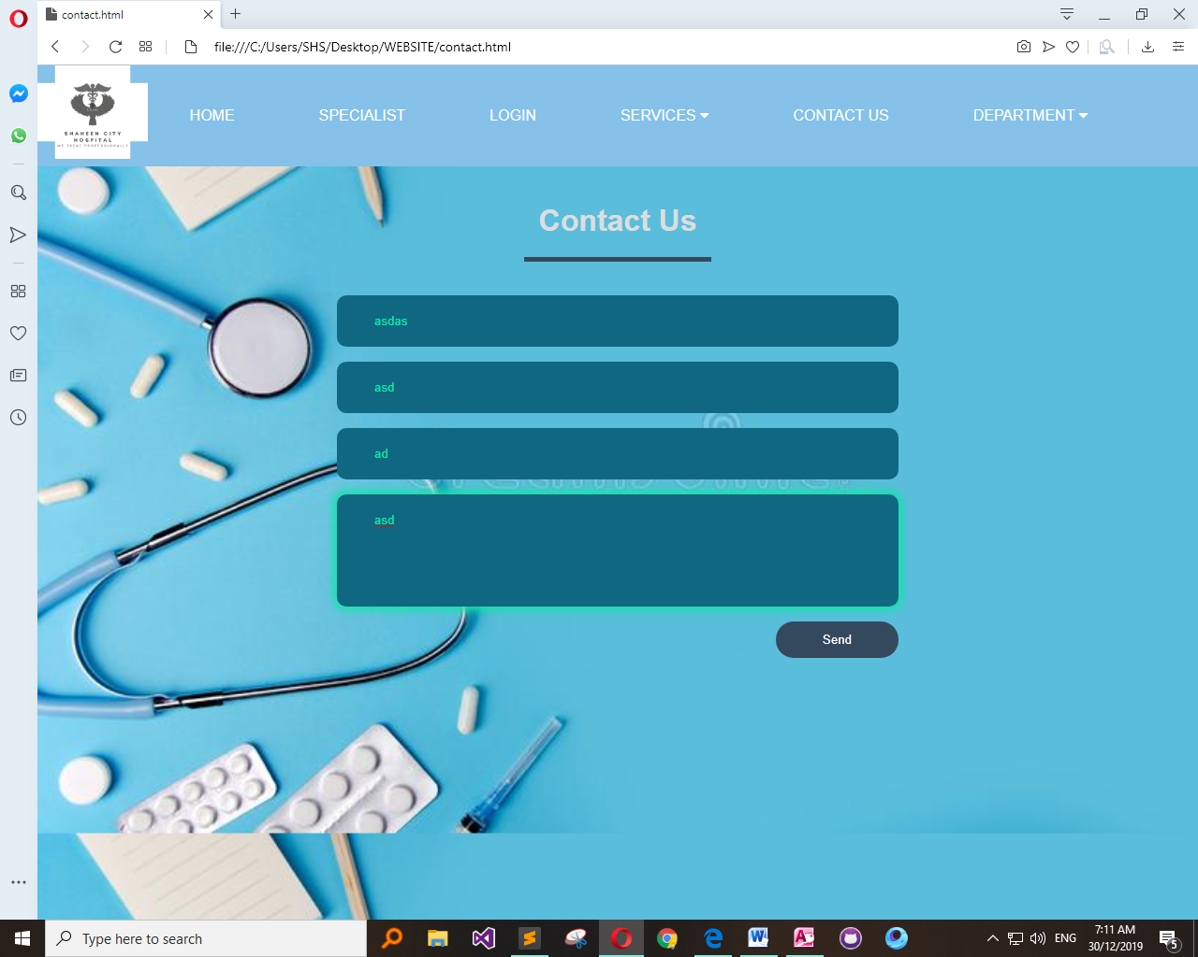

Department Page:

<!DOCTYPE html>

<html>

<head>

<title>CARDIO</title>

<link rel="stylesheet" type="text/css" href="style.css">

<link href='http://fonts.googleapis.com/css?family=Montserrat:400,700%7CPT+Serif:400,700,400italic' rel='stylesheet'>

<link href="https://fonts.googleapis.com/css?family=Montserrat|Open+Sans" rel="stylesheet">

</head>

<style type="text/css">

*{

margin:0px;

padding:0px;

}

.bgimage{

background-image: url('d2.jpg');

background-size: 100% 110%;

width: 100%;

height: 100vh;

}

.menu{

width: 100%;

height: 150px;

background-color:#5DADE2;

}

.leftmenu{

width: 30%;

line-height: 0px;

float: left;

/* background-color: yellow;*/

}

.leftmenu h4{

padding-left: 50px;

font-weight: bold;

color: white;

font-size: 25px;

font-family: 'Montserrat', sans-serif;

}

.rightmenu{

line-height: 200px;

width:70%;

height: 100px;

float: right;

/* background-color: red; */

}

.rightmenu ul{

margin-left: 100px;

}

.rightmenu ul li {

float: left;

font-family: 'Montserrat', sans-serif;

display: inline-block;

list-style: none;

font-size: 15px;

color:white;

font-weight: bold;

line-height: 200px;

margin-left: 20px;

text-transform: uppercase;

}

#fisrtlist{

color: orange;

}

.rightmenu ul li:hover{

color: orange;

}

.text{

width: 100%;

margin-top: 185px;

text-transform: uppercase;

text-align: center;

color:white;

}

.text h4{

color: grey;

font-size: 14px;

font-family: 'Open Sans', sans-serif;

}

.text h1{

font-size:62px;

font-family: 'Montserrat', sans-serif;

font-weight: 700px;

margin:14px 0px;

animation: 1.5s;

color: #3333 ;

}

.buttonone{

background-color: #212F3C;

border: none;

font-size: 12px;

font-weight: bold;

text-transform: uppercase;

line-height: 40px;

width: 300px;

font-family: 'Montserrat', sans-serif;

margin-top: 25px;

border: 3px solid white;

}

.buttonone:hover{

color: orange;

background-color: rgb(97, 106, 107);

}

.buttontwo{

background-color: #212F3C;

border: none;

font-family: 'Montserrat', sans-serif;

text-transform: uppercase;

font-weight: bold;

line-height: 40px;

border: 3px solid white;

width: 300px;

}

.buttontwo:hover{

color: orange;

background-color: rgb(97, 106, 107);

}

.navimg{

padding-left: 0px;

}

body{

margin: 0;

padding: 0;

font-family: "montserrat";

}

.team-section{

background: #f1f1f1;

text-align: center;

}

.inner-width{

max-width: 1200px;

margin: auto;

padding: 40px;

color: #333;

overflow: hidden;

}

.team-section h1{

font-size: 15px 0;

text-transform: uppercase;

display: inline-block;

border-bottom: 4px solid;

padding-bottom: 10px;

}

.pe{

float: left;

width: calc(100% / 5);

overflow: hidden;

padding: 65PX;

transition: 0.4s;

}

.pe:hover{

background: #ddd;

}

.pe img{

width: 120px;

height: 120px;

}

.p-name{

margin: 16px 0;

text-transform: uppercase;

}

.p-des{

font-style: italic;

color: #3498db;

}

.p-sm{

margin-top: 12px;

}

.p-sm a{

margin: 0 4px;

display: inline-block;

width: 30px;

height: 30px;

transition: 0.4s;

}

.p-sm a:hover{

transform: scale(1.3);

}

.p-sm a i{

color: #333;

line-height: 30px;

}

@media screen and (max-width:600px) {

.pe{

width: 100%;

}

}

body, html{

height:100%;

margin:0;

font-size:16px;

font-family:"Lato", sans-serif;

font-weight:400;

line-height:1.8em;

color:#666;

}

.pimg1, .pimg2, .pimg3{

position:relative;

opacity:0.70;

background-position:center;

background-size:cover;

background-repeat:no-repeat;

/*

fixed = parallax

scroll = normal

*/

background-attachment:fixed;

}

.pimg1{

background-image:url('32.jpg');

min-height:100%;

}

.pimg2{

background-image:url('31.jpg');

min-height:400px;

}

.pimg3{

background-image:url('39.png');

min-height:400px;

}

.section{

text-align:center;

padding:50px 80px;

}

.section-light{

background-color:#f4f4f4;

color:#666;

}

.section-dark{

background-color:#282e34;

color:#ddd;

}

.ptext{

position:absolute;

top:50%;

width:100%;

text-align:center;

color:#000;

font-size:27px;

letter-spacing:8px;

text-transform:uppercase;

}

.ptext .border{

background-color:#111;

color:#fff;

padding:20px;

}

.ptext .border.trans{

background-color:transparent;

}

@media(max-width:568px){

.pimg1, .pimg2, .pimg3{

background-attachment:scroll;

}

}

</style>

<body>

<link rel="stylesheet" href="https://cdnjs.cloudflare.com/ajax/libs/font-awesome/4.7.0/css/font-awesome.min.css">

<style>

body {

font-family: Arial, Helvetica, sans-serif;

}

.navbar {

overflow: hidden;

background-color: #85C1E9 ;

}

.navbar a {

float: left;

font-size: 16px;

color: white;

text-align: center;

padding: 40px;

text-decoration: none;

border-radius: 20px;

}

.dropdown {

float: left;

overflow: hidden;

border-radius: 20px;

}

.dropdown .dropbtn {

font-size: 16px;

border: none;

outline: none;

color: white;

padding: 45px;

background-color: inherit;

font-family: inherit;

margin: 0;

border-radius: 20;

}

.navbar a:hover, .dropdown:hover .dropbtn {

background-color: #E59866 ;

border-radius: 20;

}

.dropdown-content {

display: none;

position: absolute;

background-color: #f9f9f9;

min-width: 160px;

box-shadow: 0px 8px 16px 0px rgba(0,0,0,0.2);

z-index: 1;

border-radius: 20px;

}

.dropdown-content a {

float: none;

color: black;

padding: 12px 16px;

text-decoration: none;

display: block;

text-align: left;

border-radius: 20px;

}

.dropdown-content a:hover {

background-color: #E59866;

border-radius: 20;

}

.dropdown:hover .dropdown-content {

display: block;

border-radius: 20;

}

}

</style>

</style>

</head>

<body>

<div class="navbar">

<img src="LOGO HOSPITAL.png" alt="shaheen city hospital logo"style="float:left; height: 100px;" >

<a href="home.html">HOME</a>

<a href="specialist.html">SPECIALIST</a>

<a href="login.html">LOGIN</a>

<div class="dropdown">

<button class="dropbtn">SERVICES

<i class="fa fa-caret-down"></i>

</button>

<div class="dropdown-content">

<a href="CLINICAL NUTRITION & CAFETERIA.html">CLINICAL NUTRITION & CAFETERIA</a>

<a href="EMERGENCY CARE.html">EMERGENCY CARE</a>

<a href="CANCER CENTER.html">CANCER CENTER</a>

<a href="CARDIOLOGY.html">CARDIOLOGY</a>

<a href="FINANCIAL HELP.html">FINANCIAL HELP TO NEEDY PEOPLE </a>

</div>

</div>

<a href="contact.html">CONTACT US</a>

<div class="dropdown">

<button class="dropbtn">DEPARTMENT

<i class="fa fa-caret-down"></i>

</button>

<div class="dropdown-content">

<a href="ent.html">ENT</a>

<a href="opd.html">OPD</a>

<a href="CARDIO.html">CARDIO</a>

<a href="skin.html">SKIN </a>

</div>

</div>

</div>

</div>

<div class="div img">

<img src="hospital.gif" height="400px" width="100%">

</div>

<div class="text">

<h4> EXCELLENCE IN HEALTH CARE </h4>

<h1> SHAHEEN CITY HOSPITAL </h1>

</div>

</div>

</body>

<body>

<section class="section section-light">

<img src="C:\Users\SHS\Desktop\WEBSITE\cardio.jpg" height="400px" width="500px">

<h2><br>DR. MUHAMMAD TAHIR KAMAL SAHU</br> </h2>

<h2>ABOUT DR. MUHAMMAD TAHIR KAMAL SAHU</h2>

<p>

Dr.Muhammad Tahir Kamal Sahu is a cardiologist at Shaheen City Hospital.

</p>

<h3>QUALIFCATIONS</h3>

<p>MBBS(Quaid azam medical college,Bahawalpur,University of the punjab,Lahore,Pakistan) 1983,

Diploma in cardiology(National institute of cardiovascular disease,Karachi,Pakistan) 1993.

</p>

<h3>EXPIREINCE</h3>

<p>Senior house officer,Bahawal victoria hospital,Bahawalpur.1983 To 1984,

Medical officer,Bahawal victoria hospital,Bahawalpur, 1984 To 1985,

Medical officer, Rural areas,Pakistan. 1985 To 1988,

Registrar/RMO, CC, Cardiology & emergency wards,Nishtar hospital & medical college,Multan,Pakistan 1988-1990,

Registrar / RMO, CCU, Cardiology & emergency wards ,Punjab institute of cardiology,Lahore,Pakistan. 1992-1993,

Interventional cardiologist, Department of cardiac catheterization & interventional cardiology,Punjab institue of cardiology,Lahore,Pakistan. 1993-2000.</p>

<h3>SPECIAL INTEREST</h3>

<p>Clinical and interventional cardiology,

Endovascular intervention.

</p>

<h3>WORKSHOPS ETC.</h3>

<p>Attended several national and international conference and workshops.</br></p>

<h3>Personal webpage</h3>

<p>No personal webpage.</p>

</section>

<div class="pimg1">

<div class="ptext">

<span class="border">

THANK U VISITING OUR WEBSITE

</span>

</div>

</div>

</body>

<footer>

<div class="team-section">

<div class="inner-width">

<h1>Meet Our Team</h1>

<div class="pers">

<div class="pe">

<img src="H1.jpg" alt="HAMZA">

<div class="p-name">HAMZA</div>

<div class="p-des">CHEIF EXECUTIVE OFFICER</div>

<div class="p-sm">

<a href="#"><i class="fab fa-facebook-f"></i></a>

</div>

</div>

<div class="pe">

<img src="H2.jpeg" alt="HANAN">

<div class="p-name">ABDUL HANAN</div>

<div class="p-des">DEVELOPING VICE HEAD</div>

<div class="p-sm">

<a href="#"><i class="fab fa-facebook-f"></i></a>

</div>

</div>

</div><div class="pe">

<img src="H3.jpg" alt="HARIS">

<div class="p-name">HARIS SARWAR</div>

<div class="p-des">WEB-DESIGNER</div>

<div class="p-sm">

<a href="#"><i class="fab fa-facebook-f"></i></a>

</div>

</div>

</div>

</div>

</footer>

</html>

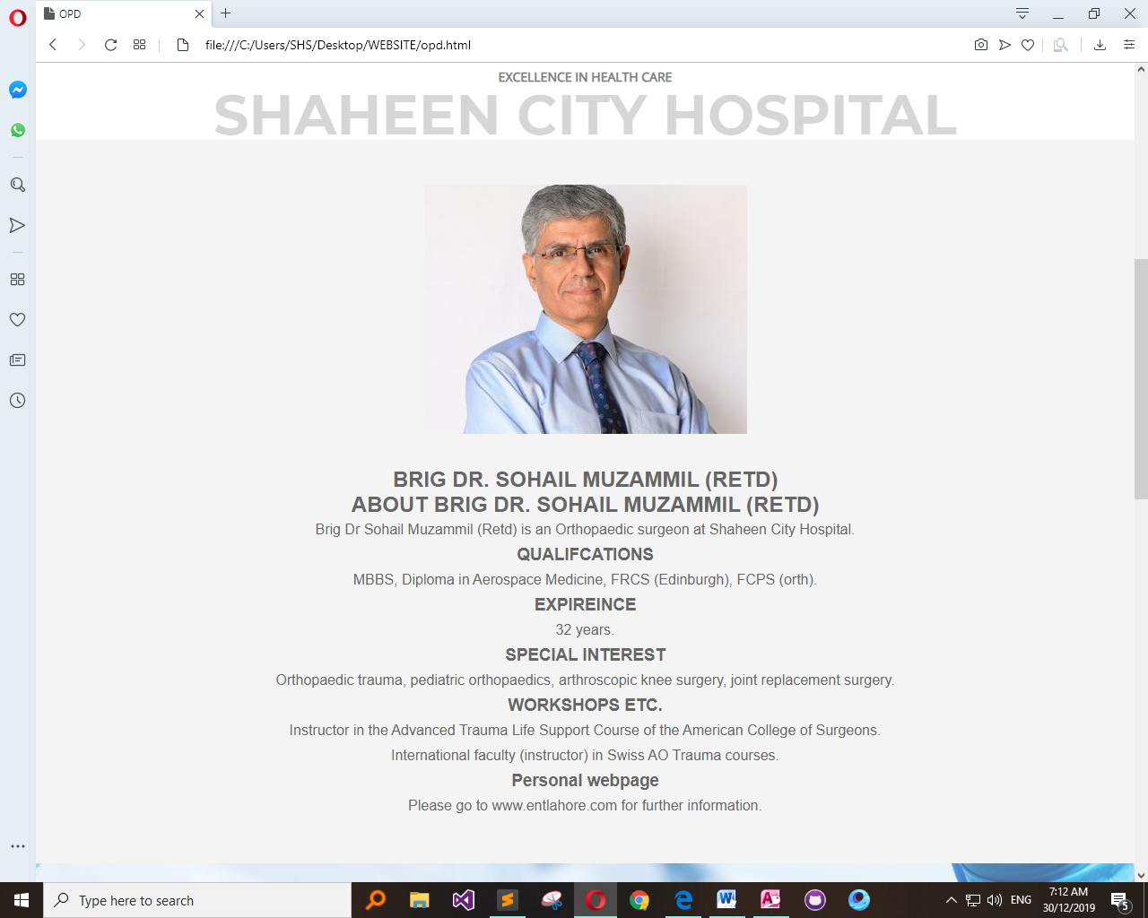

1. **PRESENTATION:**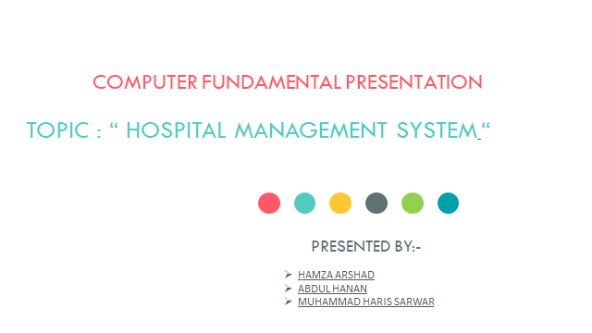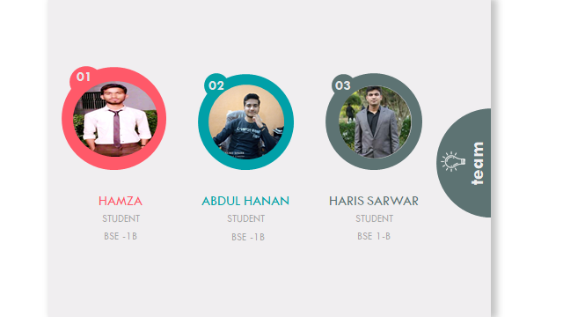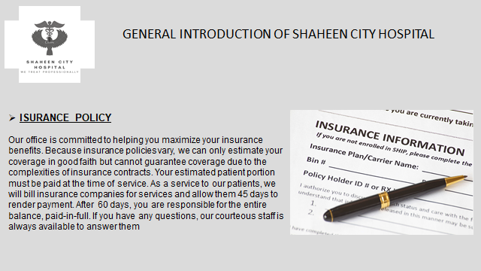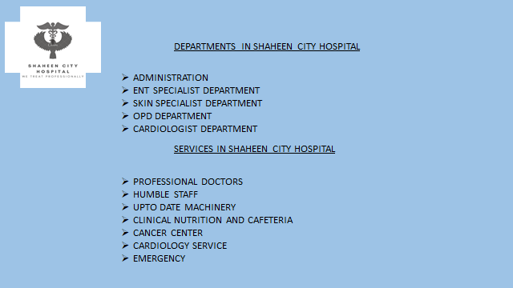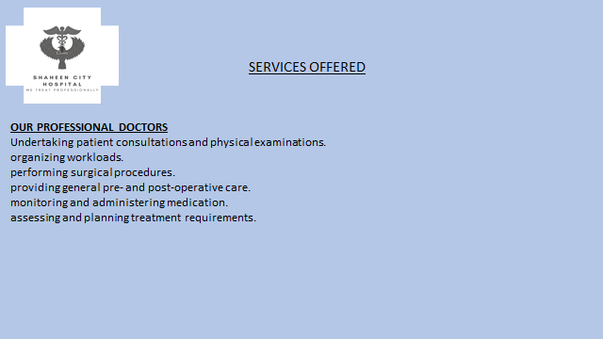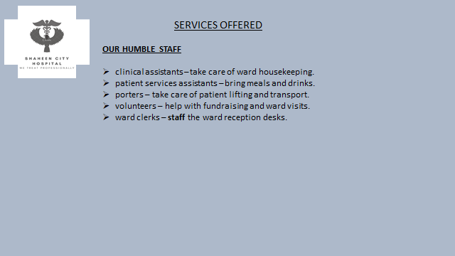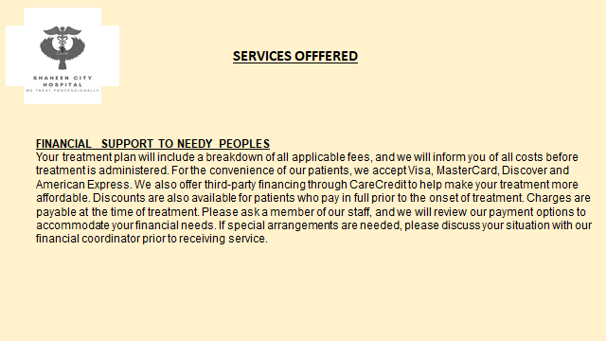
2. **PROGRAMS:**1. MS Access.2. Sublime.
3. **CONCLUSION:**

This project contains Database and website of hospital system. We use different things to accomplish the task in this project in MS Access we create Forms, Reports and Tables of doctor and patient. In Webpage we create different pages using navigation bar that contain About, Contact, Home and Doctor.